

IST 736 Text Mining | Section M400





Antonio Luina

Bhavya Madhavan

Daphne Chang

Tamilselvan Tamilmani

March 2021

Table of Contents

Introduction 2

Work From Home: Not a New Phenomenon 2

The New Normal 2

The Business Issue 3

Analysis and Models 4

About the Data 4

Twitter Data 4

Reddit Data 8

Data Pre-processing 10

Sentiment Analysis 12

Data Preparation 12

Stemming, Lemmatization, and Vectorization 13

Data Sampling 13

The Models 14

Topic Modeling 16

Data Preparation 16

Topic Models 17

Genism LDA Model 17

Sklearn LDA Model 17

Visualizing the "Shapes" of Topics 17

Results 18

Sentiment Analysis 18

Recommendations 19

Topic Modeling 20

Latent Dirichlet Allocation (LDA) 20

Conclusion 26

How Do People Feel 26

What Is on People's Minds 27

Recommendations 27

Appendix 28

Sentiment Analysis Results Of All Models 28

# Introduction

## Work From Home: Not a New Phenomenon

Throughout history, everyone worked out of their homes. A blacksmith had his shop at home; a woodworker had his workshop at home. As the industrial revolution began, the need for big factories and having people work increased; more people left their crafts to go and work for big factories, as the economy drove them. As time passed and World War II boosted the economy, new headquarter offices opened, there was more office space, and more employees working in offices.

The Internet era changed that again. Many people got the opportunity to start working from home, though it was not as popular as it is becoming today. Over the last few years, working from home increased gradually until early 2020, when the COVID-19 pandemic hit the world[1].

## The New Normal

Because of the COVID-19 pandemic, thousands of workers in the U.S. have been forced to work remotely. According to a Forbes report[2], "Pre-pandemic, roughly five percent of full-time employees with office jobs worked primarily from home. That figure is likely to settle at 20-30 percent in the new normal." A survey by the Pew Research Center[3] shows that 20% of employees worked from home all or most of the time before the pandemic, 71% currently work from home, and 54% would like to work from home after the pandemic ends (Figure 1). Most of them have found it very easy or somewhat easy to work from home.

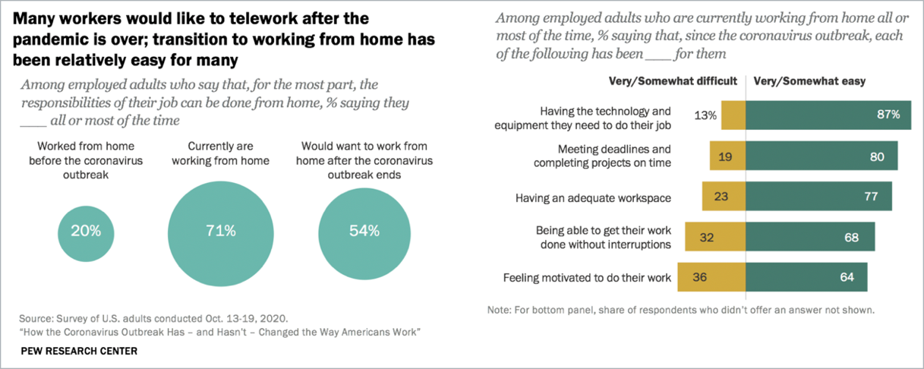

Figure 1. Transition to Remote Working Is Easy for Most People

## The Business Issue

At Big Business U.S.A, 90% of the workforce from business locations across the country have been working from home since April 2020. As employees have settled into the new normal of remote work, many have expressed an interest in working from home after the pandemic. Responding to the staff's voice, C-level executives have requested the Human Resources (HR) department to draft a new work-from-home policy. To come up with a work-from-home strategy, as the first step, the HR department would like to know how people feel about working from home in general, and what else is on people’s mind relating to working from home. Has the COVID-19 pandemic impacted people's attitudes and thoughts?

The Data Team of the HR department was tasked to conduct the study. Comparing how people feel about working from home before and during the pandemic will help the HR department understand whether there is indeed a changing trend in people's remote work preferences in society. Employees' voices are not isolated cases. Getting to know what is on people’s minds when talking about working from home, before and during the pandemic, will shed some light on what people have coped with when working from home and if the pandemic has impacted the extent of things with which they have to cope. In addition, the methods presented in the study can be used to automatically identify people's attitudes and thoughts expressed in new social media postings. This report summarizes the analysis and results of the study.

# Analysis and Models

## About the Data

There were two data sources for this study: Twitter and Reddit posts. Why choose Twitter and Reddit? Twitter is a social media giant. It has been considered as "the best indicator of the wider pulse of the world and what's happening within it."[4] Reddit is a news discussion website on which the user aggregates news by posting links for other users to vote and comment. It is another popular social media website in the U.S.[5]. The combination of postings from both social media platforms gives a good indication of what is on people's minds.

Both websites were queried using three keywords, "WFH," "workingfromhome," and "workfromhome." Twitter was searched using those keywords with hashtags "#" and Reddit with those words as keywords. Only English language postings that were geographically tagged as United States was retrieved because Big Business U.S.A. only has business locations in the United States.

For sentiment analysis, the Transformer library's Sentiment Analysis tool[6] was used to generate the sentiment labels for the training data used on the models that make sentiment predictions.

### Twitter Data

The Twitter data was collected using Twitter academic research API. The tweets from January 2019 to February 2021, excluding retweets and ads, were extracted. The resulting JSON data was converted to a CSV file for analysis. The query resulted in almost 30K tweets. The tweets were then labeled using the Transformer library's tool. Figure 2 gives a snapshot of the labeled data.

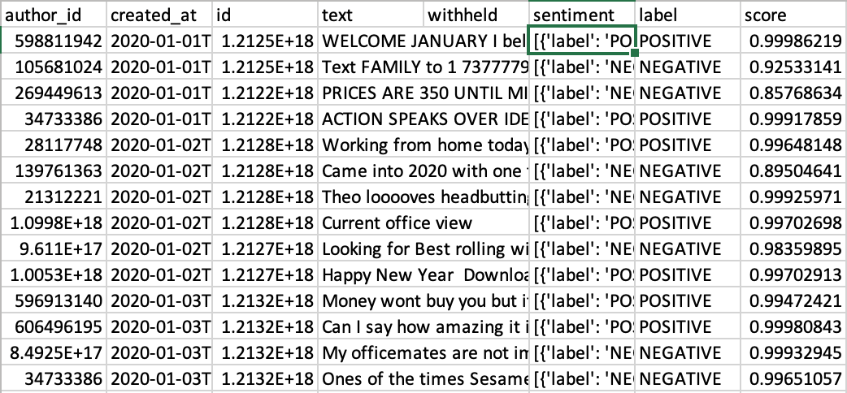

Figure 2. Snapshot of the Labeled Twitter Data

Table 1 shows the column definition for the tweets after applying the Transformer library's Sentiment Analysis tool. For this analysis, only created_at, text, and label columns were used.

Table 1. Twitter Data Column Definition

|  |  |  |
| --- | --- | --- |
| Column Name | Type | Description |
| Author ID | datetime | The poster's tweeter account id |
| created_at | Text | Represents the date on which the tweets are created |
| text | Object | Describes the content of the tweets |
| sentiment | Object | Dictionary of the result of Transformer Sentiment |
| label | Categorical | POSITIVE for positive sentiment, NEGATIVE for negative sentiment. |
| score | Real | The score of the prediction. 0 means low reliability, 1 being the best. |

Figure 3 shows the distribution of tweets over time. The Topic of working from home became very popular in March and April last year when the COVID-19 pandemic became prevalent enough in the U.S. to result in stay-at-home orders and ultimately resulted in most of the population working from home. The Topic gradually quieted down but still at a level much higher than before the pandemic started.

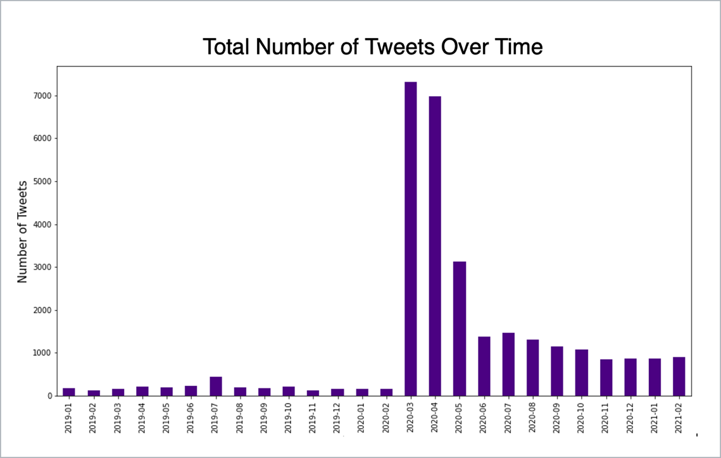

Figure 3. Frequency of Tweets by Month

The distribution of positive and negative tweets over time is shown in Figure 4. The sentiments appear to be evenly distributed over time, except for March when there were slightly more negative tweets.

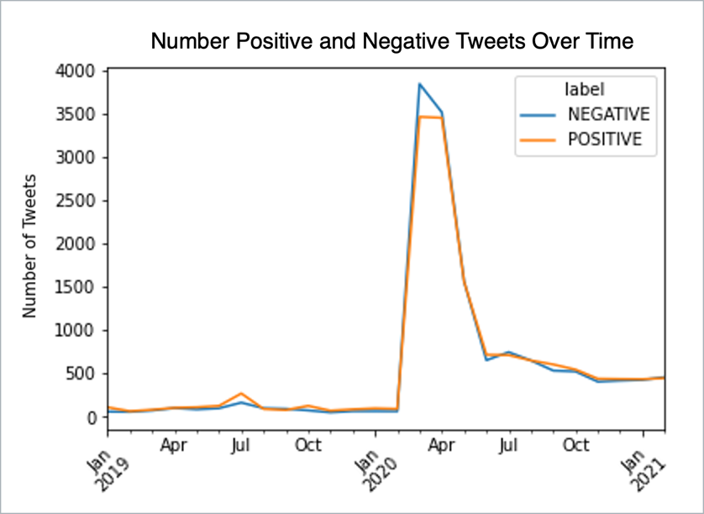

Figure 4. Distribution of Labels by Month

The top 30 hashtags of the collected tweets before and after the pandemic started are shown in Figure 5 and Figure 6.

Before the pandemic, the top five hashtags were about "entrepreneur," "business," "the art of thinking out loud," healthy lifestyle," and "accountability."

After the pandemic started, the top five hashtags became about "COVID-19," "coronavirus," "remote work," "stay home," and "quarantine," which were all related to the same Topic of COVID-19.

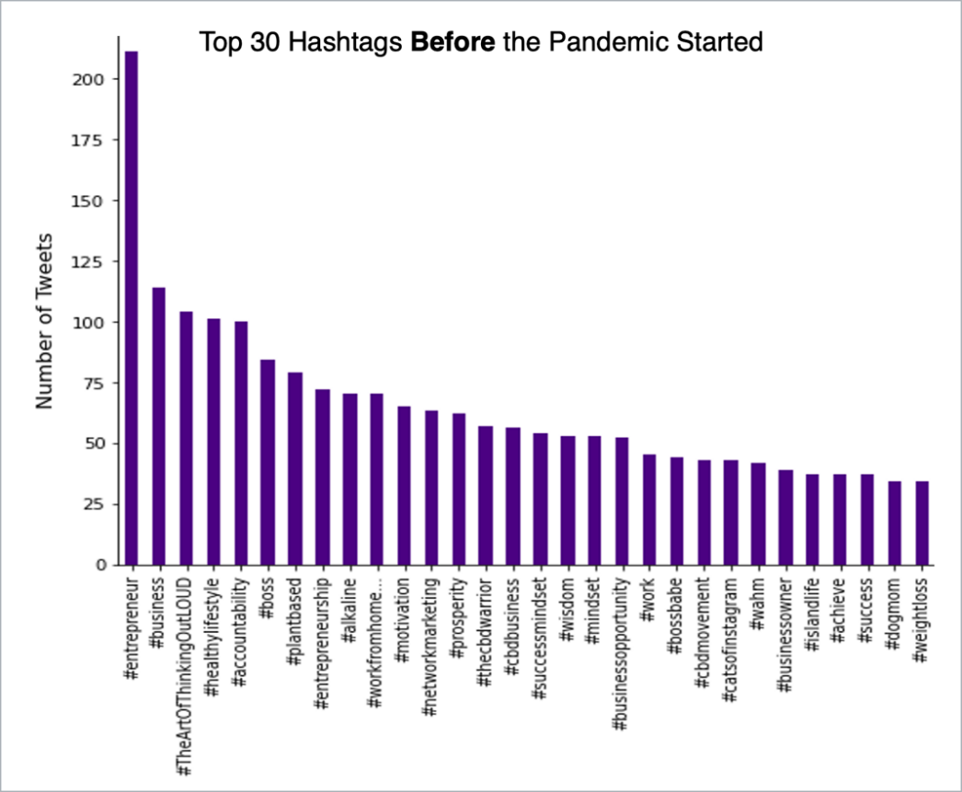

Figure 5. Top 30 Hashtags Used by Twitter Users Before the Pandemic Started

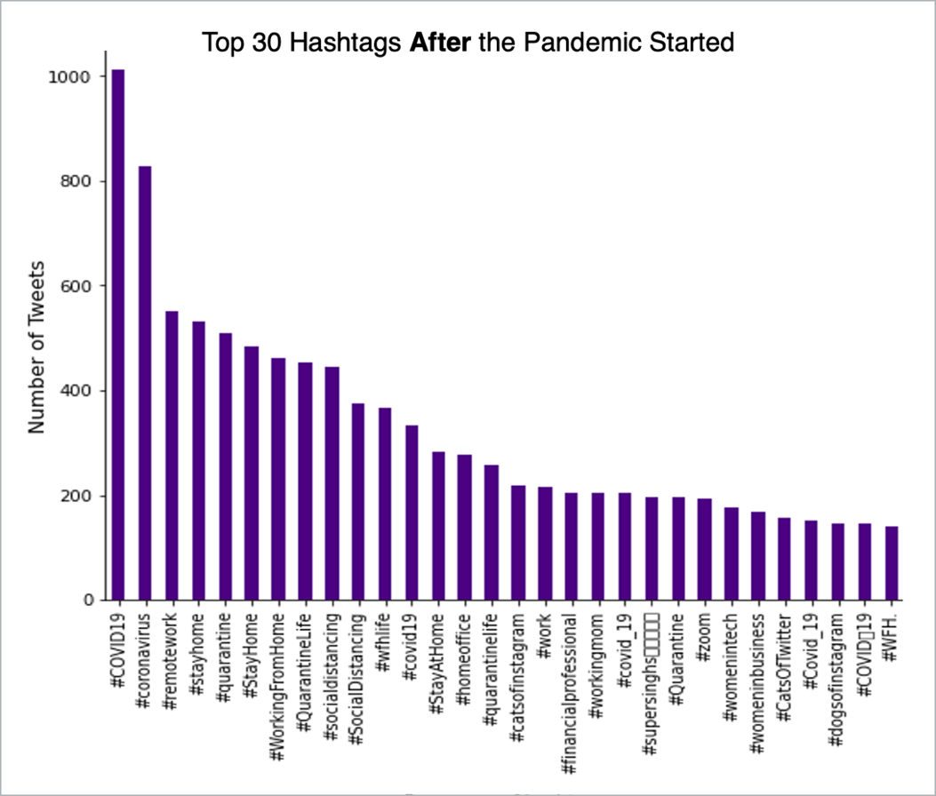

Figure 6. Top 30 Hashtags Used by Twitter Users After the Pandemic Started

### Reddit Data

Reddit was queried for the three keywords, "wfh," "workingfromhome," and "workfromhome," starting with January 2019, going month by month until February 2021. The extracted posts were saved into CSV Files, one per month. The resulting data consists of almost 3280 posts. The month-by-month files were processed and labeled.

Figure 7. Data Progression from Posts to Labeled Data shows how the data progressed.

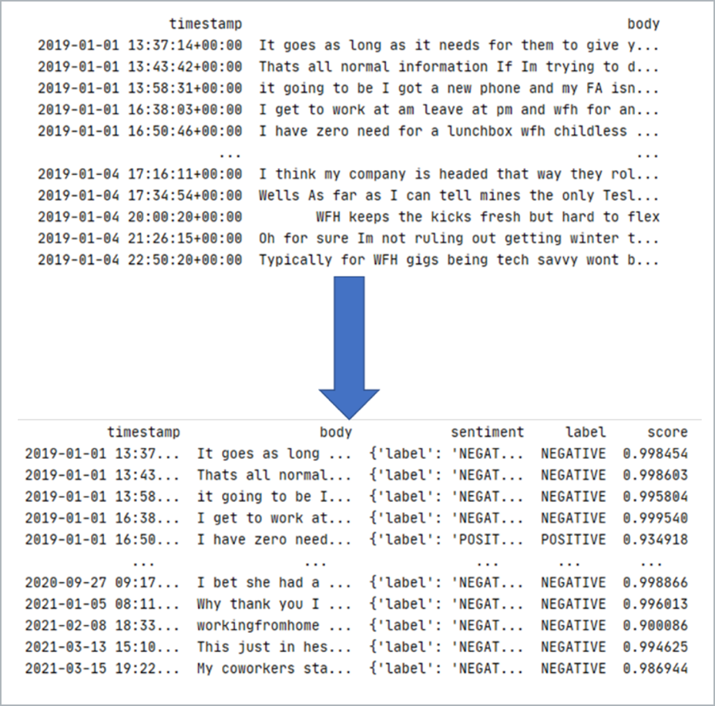

Figure 7. Data Progression from Posts to Labeled Data

The data ended up with five columns. Table 2 shows the definitions of its columns.

Table 2. Reddit Data

|  |  |  |
| --- | --- | --- |
| Column Name | Type | Description |
| Timestamp | datetime | Time that the post was made. |
| body | Text | Represents the content of the post. |
| sentiment | Object | Dictionary of the result of Transformer Sentiment |
| label | Categorical | POSITIVE for positive sentiment, NEGATIVE for negative sentiment. |
| score | Real | The score of the prediction. 0 meaning low reliability, one being the best. |

The distribution of Reddit post counts is shown in Figure 8. Posts on the Topic of "work from home" appeared with a relatively similar frequency, except for March 2020, which was about the pandemic's beginning.

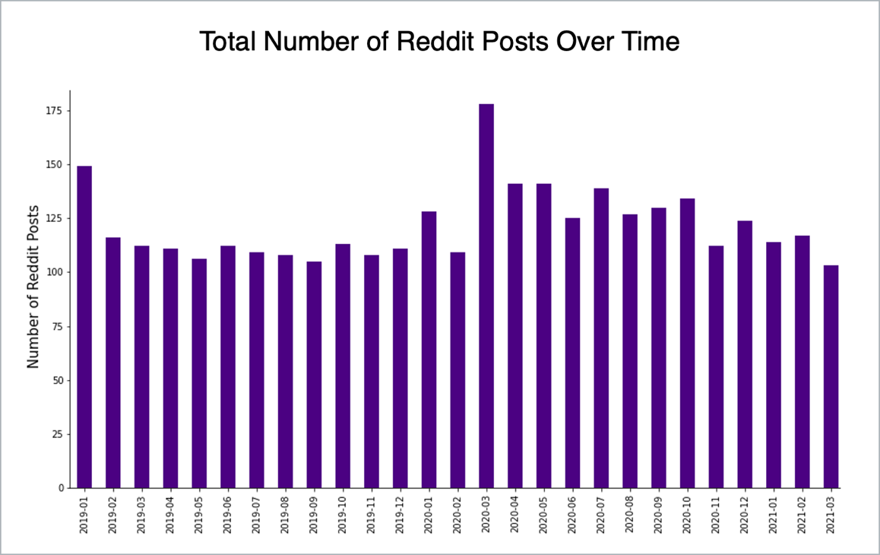

Figure 8. Frequency of Reddit Posts by Month

The distribution of positive and negative posts over time is shown in Figure 9. More Reddit posts had a negative sentiment, especially in March 2020, about the time when the pandemic began.

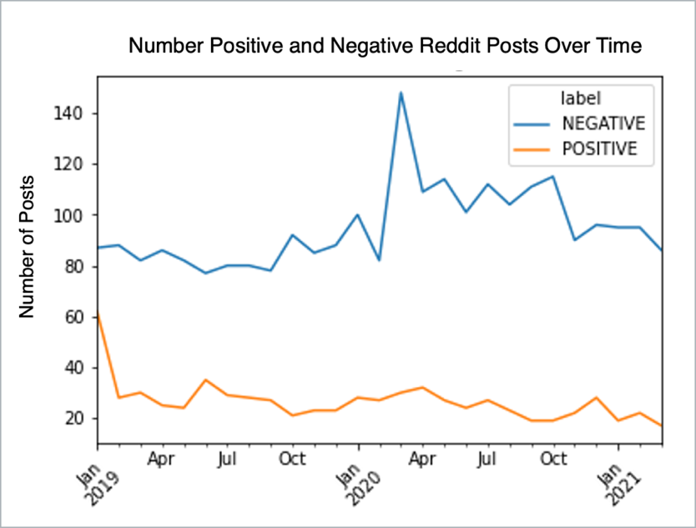

Figure 9. Distribution of Positive and Negative Posts by Month

Both the datasets, Tweets and Reddit posts, were combined before the analysis was performed.

## Data Pre-processing

The raw data collected from both Twitter and Reddit consisted of many words or characters which were not relevant for the analysis. As seen from Figure 10 and Figure 11 below, the data needed extensive cleaning before text mining tools could be applied.

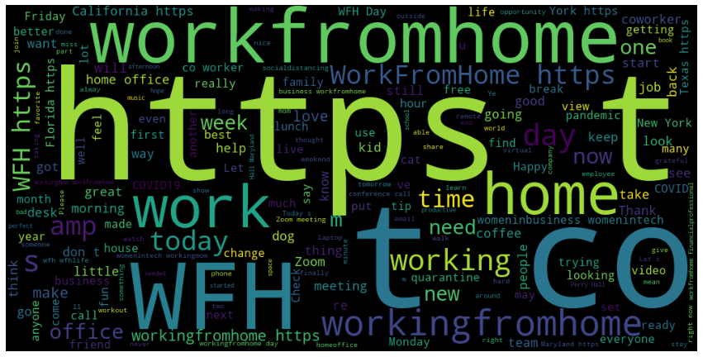

Figure 10. Word Cloud One: Posts before Cleanup

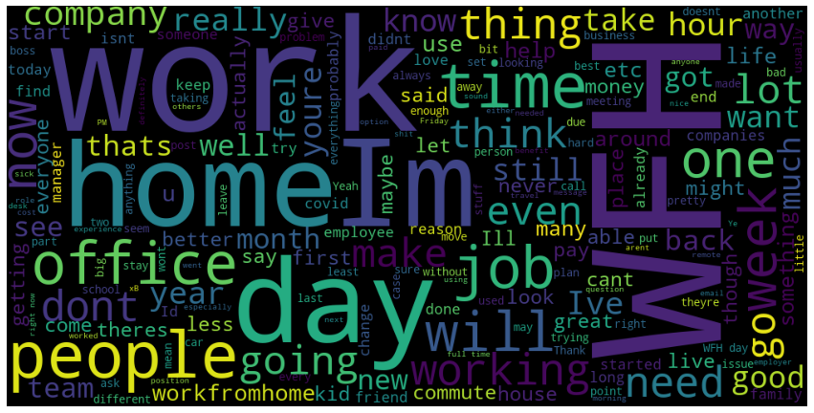

Figure 11. Word Cloud Two: Posts Before Cleanup

The following data cleaning steps were performed for both Twitter and Reddit posts (Figure 12):

1. Converting all words to lower case.
2. Replacing .com with dotcom to track websites.
3. Converting any escaped characters to text like tab (\t) or newline character (\n).
4. Removing anything that was not a letter.
5. Removing extra spaces.
6. Removing numbers.
7. Removing keyword tags and hashtags from all posts.
8. Removing empty rows.
9. Removing duplicates.

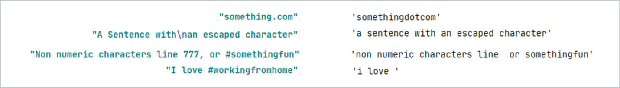

Figure 12. Example of How Posts Were Cleaned Up During the Process of Vectorization

After cleaning, the dataset ended up with 31,859 records. Figure 13 shows the distribution of sentiments in the dataset.

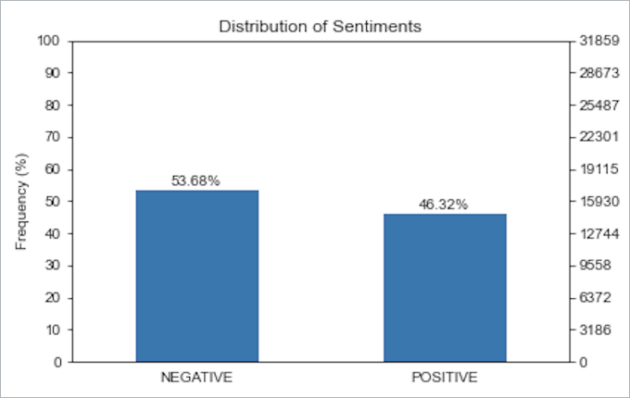

Figure 13. The distribution of sentiments in the dataset

## Sentiment Analysis

### Data Preparation

Sentiment analysis was conducted on the combined dataset. Since the data was retrieved from different sources, posts were read individually and then merged; they were read into one data frame, divided into "body" and "labels." Other columns were ignored. Then the labels were split from the training data. Figure 14 shows how the data was read and organized.

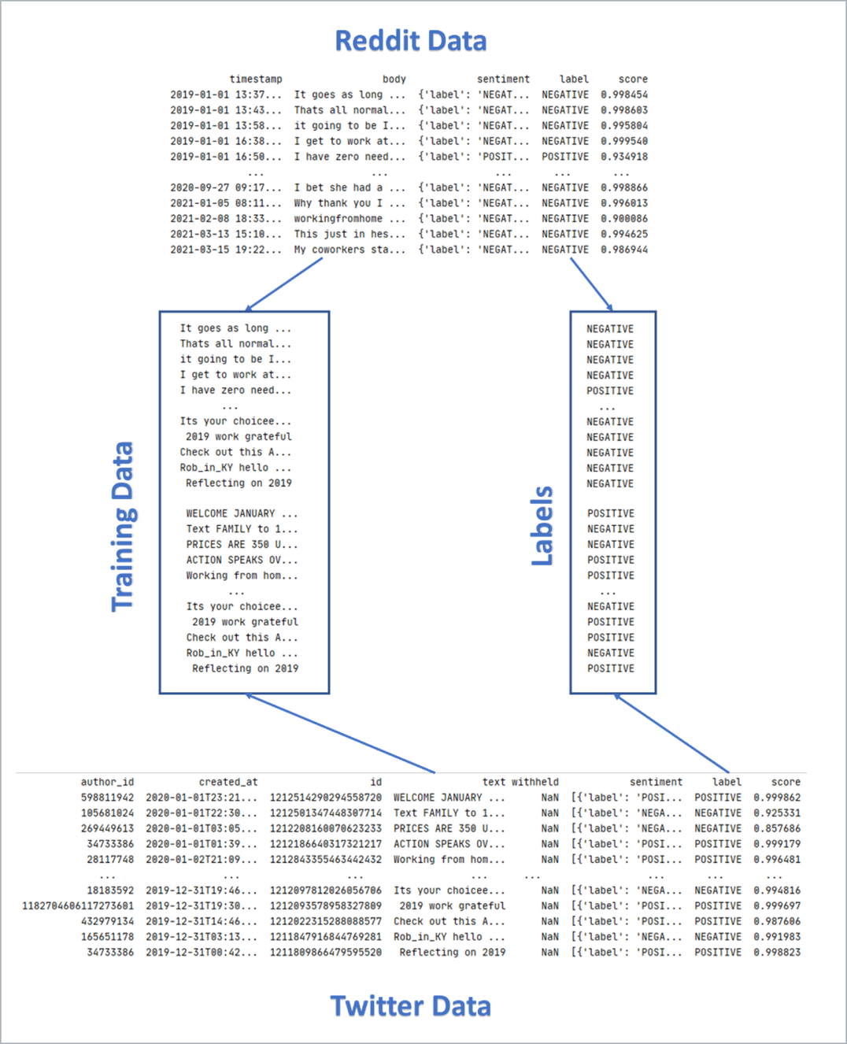

Figure 14. Sentiment Analysis Data Flow

### Stemming, Lemmatization, and Vectorization

The cleaned dataset was stemmed using the Porter Stemmer and Snowball Stemmer in Python's nltk library, lemmatized using the WordNet Lemmatizer method in Python's nltk library and vectorized using the Count Vectorizer method and the TF/IDF Vectorizer in Python's Sklearn library.

Lemmatization and stemming[7] are two standard text pre-processing techniques to reduce the size of the total words in the text, thus reducing the dimensional space of vectors to capture the essence of the data and reduce noise. Lemmatization reduces inflectional forms of words based on a vocabulary and the morphological analysis of words. Unlike stemming, lemmatization only removes inflectional endings of a word to return it to its dictionary form, known as the lemma. Stemming, on the other hand, chops off the ends of words; there is a risk of over-stemming when too many letters in a word get chopped off; consequently, its word's stem no longer carries recognizable meaning. Or two words with totally different meanings can be chopped off to the same stem. In this task, both lemmatization and stemming methods were used to compare the difference in the outcome.

In this study, four vectorizers were used: Binary, Term Frequency, Normalized Term Frequency, and Term Frequency/Inverse Document Frequency (TF/IDF). Vectorized matrices were created: 1) without stemming/lemmatization, 2) with the Porter Stemmer, 3) with the Snowball Stemmer, and 4) with the WordNet Lemmatizer.

The data frames created from stemming, lemmatization, and vectorization were used to train a combination of 136 models. Figure 15 shows the combination that resulted in 136 models.



Figure 15. The 136 Combinations of Modeling Analysis

### Data Sampling

After several attempts to run the modeling analysis with the entire dataset, the Data Team realized that its computing resources could not handle the whole dataset. Thus, it was decided that a sample set of 5,000 posts with a balanced distribution of negative and positive labels would be randomly selected for this study.

### The Models

Two types of supervised machine-learning models were used to conduct the sentiment analysis were the Naïve Bayes and the Support Vector Machine model.

#### Naïve Bayes

Naïve Bayes, a popular algorithm based on the classic Bayes theorem, uses prior and conditional probabilities to calculate posterior probability, which is the probability that a piece of data belongs to a class. Naïve Bayes classifiers' advantages include ease of implementation, low computation cost, effectiveness with datasets of any size, and exemplary performance in text classification problems[8].

Naïve Bayes algorithm was run using Multinomial and Binomial models. The Multinomial models were run with Term Frequency, Normalized Term Frequency, and TF/IDF vectorizers. The Binomial Naïve Bayes models were run only using Binary vectorizers.

#### Support Vector Machines (SVMs)

Support Vector Machine (SVM), a widely used algorithm for two-group classification problems, finds the right hyperplane in N-dimensional space (N = the number of features) that distinctly separates the data points into two groups (Figure 15). SVMs are well-regarded for their effectiveness in high-dimensional spaces with relatively less computation power.

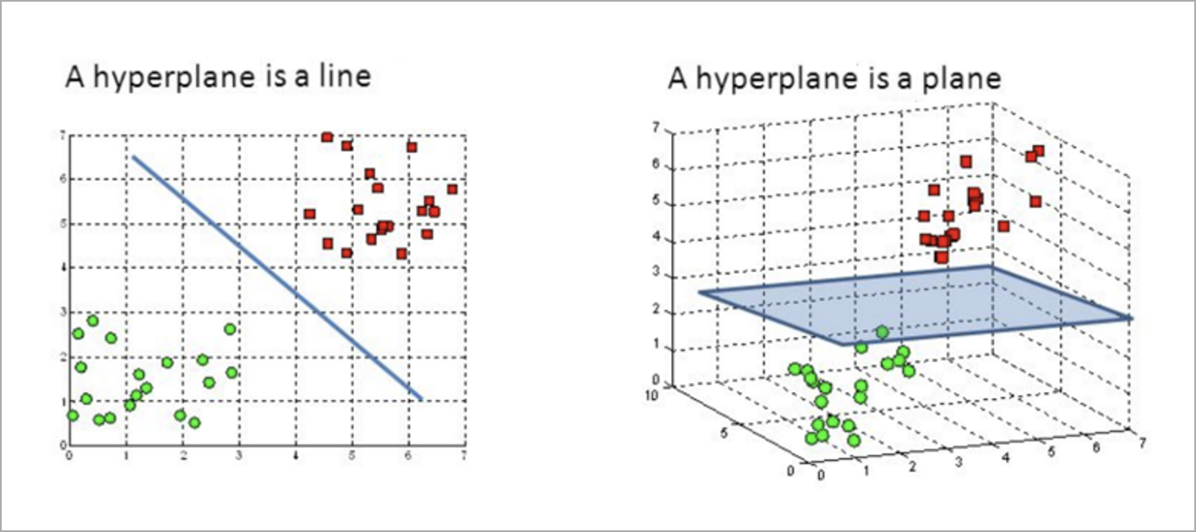

Figure 16. Hyperplanes in 2D and 3D feature space[9]

The SVMs were run with linear, polynomial, and Radial Basis Function (RBF) or Gaussian kernels. Each of the kernels was run with a cost of 0.001, 1.0, and 1000. The models were run with Term Frequency, Normalized Term Frequency, and TF/IDF vectorizers.

A total of 136 models were built following the same process of modeling analysis. Models were evaluated using a 20-fold cross-validation method. Each fold followed the same process. The sample dataset was divided into 70% training data and 30% testing data for each fold using a stratified split. A random seed value was set so the results can be replicated.

For each of the 20 folds, first, the training and test sets were determined. The model was created using the training data, test labels were predicted on the testing data, and the accuracy score and the confusion matrix were calculated. Then, the top words for each class were extracted. Lastly, the best prediction score was saved. After all the 20 folds were calculated, the average score was determined. Figure 16 shows a flowchart of the process to calculate the accuracy and the models.

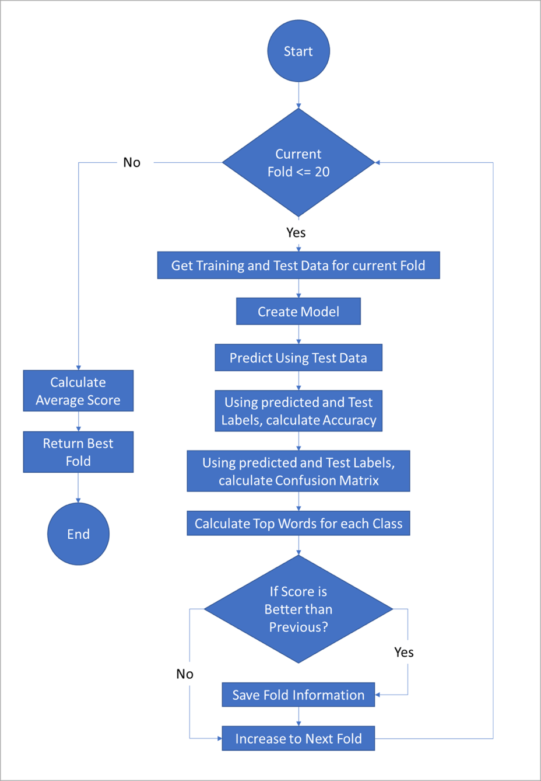

Figure 17. The 20-fold Cross-Validation Method

## Topic Modeling

Latent Dirichlet Allocation (LDA) models were built to uncover the hidden topics in the Twitter and Reddit posts.

LDA is a popular topic modeling technique, a branch of unsupervised natural language processing used to uncover underlying topics in a text document. The concept behind LDA is: "A distribution of topics can describe each document, and each topic can be described by a distribution of words," as stated by Ganegedara in his article explaining LDA[10] (Figure 18). The goal of topic modeling is to reveal the hidden (i.e., latent) topics in each document by the probability distribution of words in the document.

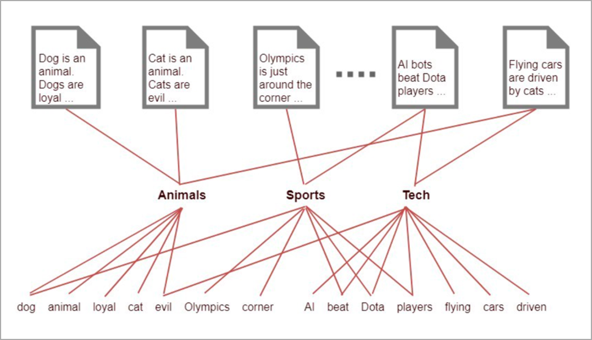

Figure 18. Words are modeled by a set of topics and a set of topics models documents   
*Credit: Thushan Ganegedara, 2018*

### Data Preparation

A Bag of Word (BoW) corpus was created for the LDA model from the genism library. The Twitter and Reddit data were tokenized using the spaCy library and lemmatized using WordNet Lemmatizer from Python's nltk library. The same cleaning steps described in the Data Pre-Processing section were applied. The cleaned texts were passed to the doc2bow function from the genism library's corpora module and were converted into the BoW corpus.

Besides, the TF/IDF Vectorizer in Python's Sklearn library was used to vectorize the cleaned posts for use with the model built with the Sklearn library's LatentDirichletAllocation method. The TF-IDF vectorizer converted the posts into a matrix of normalized token counts. The document-term matrix is a two-dimensional array with each column corresponding to the unique word in the list of posts supplied. Each row contains the values of normalized word frequencies/inverse document frequencies (TD-IDF) in a post.

## Topic Models

Two LDA models were trained: one based on the BoW corpus and the other based on the TF-IDF matrix. Latent Dirichlet Allocation (LDA) is a generative statistical model that allows sets of observations to be explained by unobserved groups that explain why some parts of the data are similar. The LDA algorithm tries to classify the documents based on how similar they are in their structure[11].

### Genism LDA Model

An LDA model was built using the BoW corpus. Initially, 30 topics were selected. For evaluating the number of topics (k) for the model, the coherence scores for different K were calculated. Topic coherence scores quantify the coherence of a topic by "measuring the degree of semantic similarity between its high scoring words."[12]

Fifty passes were kept, the minimum probability was set at 0.5, and alpha was set to auto to optimize the results.

### Sklearn LDA Model

Using Python Sklearn library's LatentDirichletAllocation method, an LDA model was trained on the TF-IDF vectorized data. The number of topics was set at 125, based on the coherence scores from the genism library's coherence model function[13].

### Visualizing the "Shapes" of Topics

To visualize the "shape" (the probability distributions of the top 30 words) of each Topic, an interactive visualization for each model was created using Python's pyLDAvis library. Visualizing the shape of the topics for posts is an easier way to compare whether the topics are similar or dissimilar visually.

# Results

## Sentiment Analysis

A total of 136 models were trained and tested on the sample data of 5,000 posts. Of the 136 models, the one with the best F1-score and accuracy was the linear kernel SVM, with a Cost of 1000, using a TF/IDF vectorizer, with the Snowball Stemmer.

Figure 19 shows the top 5 models based on F1-scores.

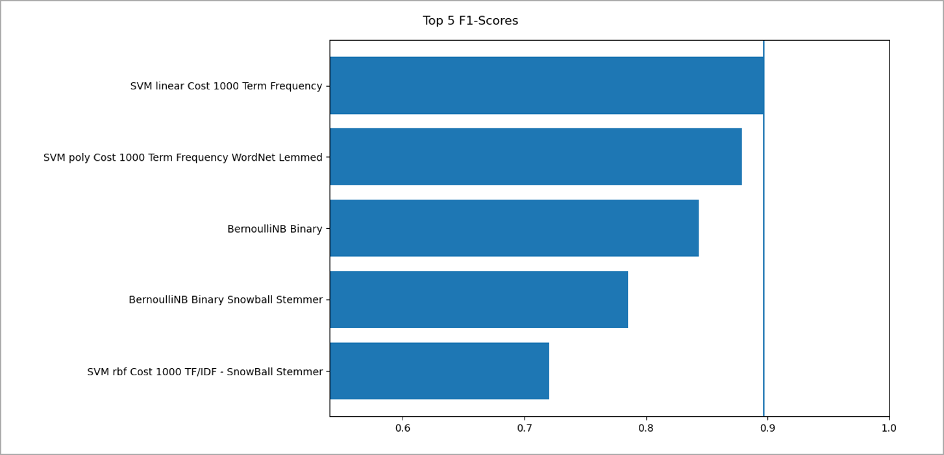

Figure 19. Top 5 Models Based on F1-scores

Figure 20 shows the top 5 Confusion Matrices.

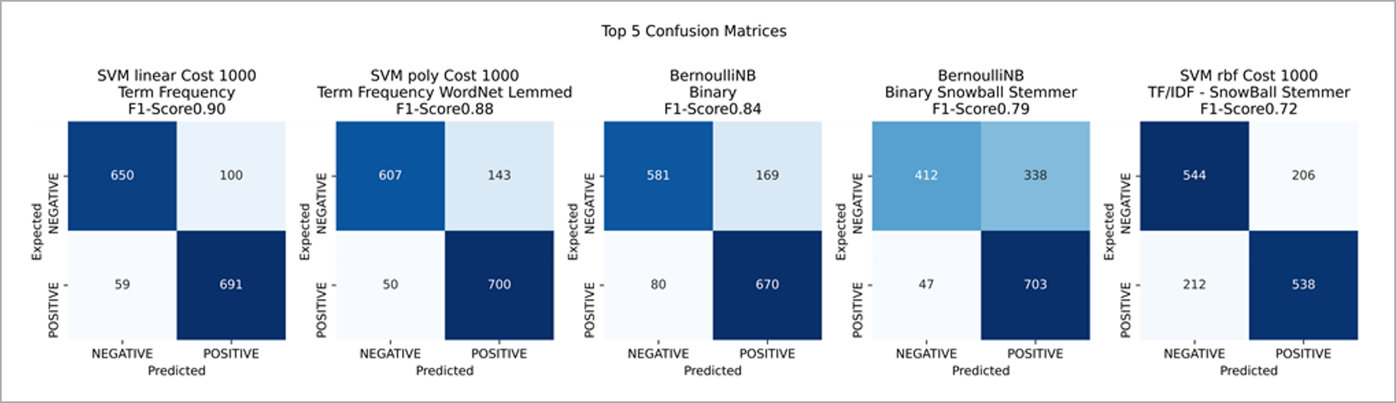

Figure 20. Top 5 Confusion Matrices

Figure 21 shows the top words from the best model. The blue bars and red bars indicate the top words corresponding to positive and negative sentiments, respectively.

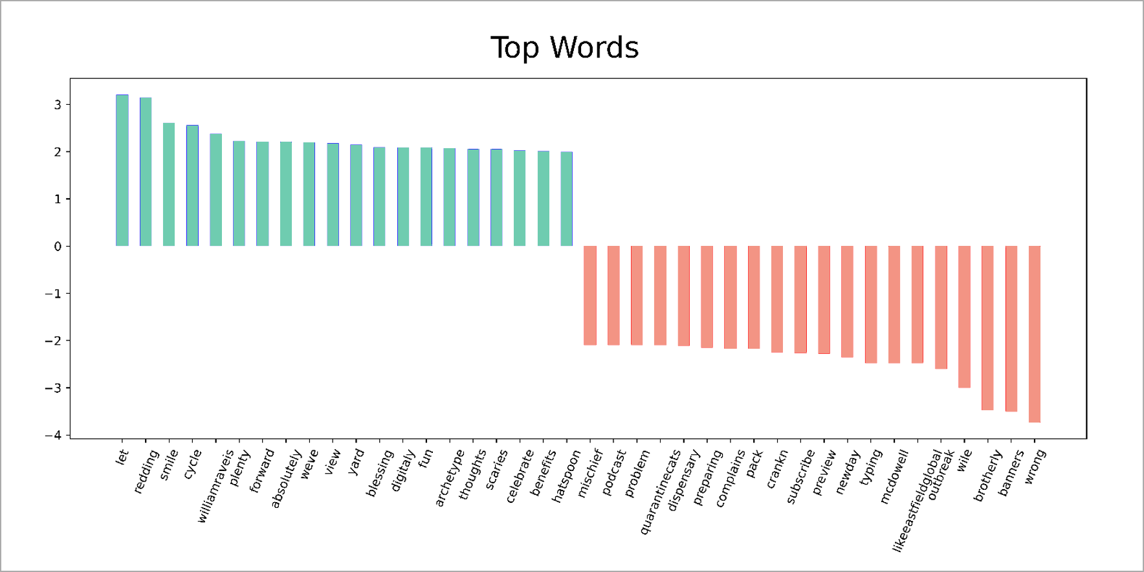

Figure 21. Top Words from the Best Model

### Recommendations

The sentiment analysis was done using a portion of the data due to its long runtime and computing consumption. It is recommended that the research is run using a high-performance cluster (HPC) with more computing power to get the SVM model trained based on the entire data set. Besides, the number of costs trained was limited due to the time it was taking to run. If run in an HPC, more cost variance should be added.

## Topic Modeling

### Latent Dirichlet Allocation (LDA)

A set of statements or facts is said to be coherent if they support each other. Thus, a coherent fact set can be interpreted in a context that covers all or most of the facts. Topic Coherence measures a single topic's score by measuring the degree of semantic similarity between high-scoring words in the Topic. These measurements help distinguish between semantically interpretable topics and topics that are artifacts of statistical inference[14].

Since the highest coherence score was 125 topics, the number of topics was set as 125. Figure 22 shows how the coherence score peaked at 125 topics.

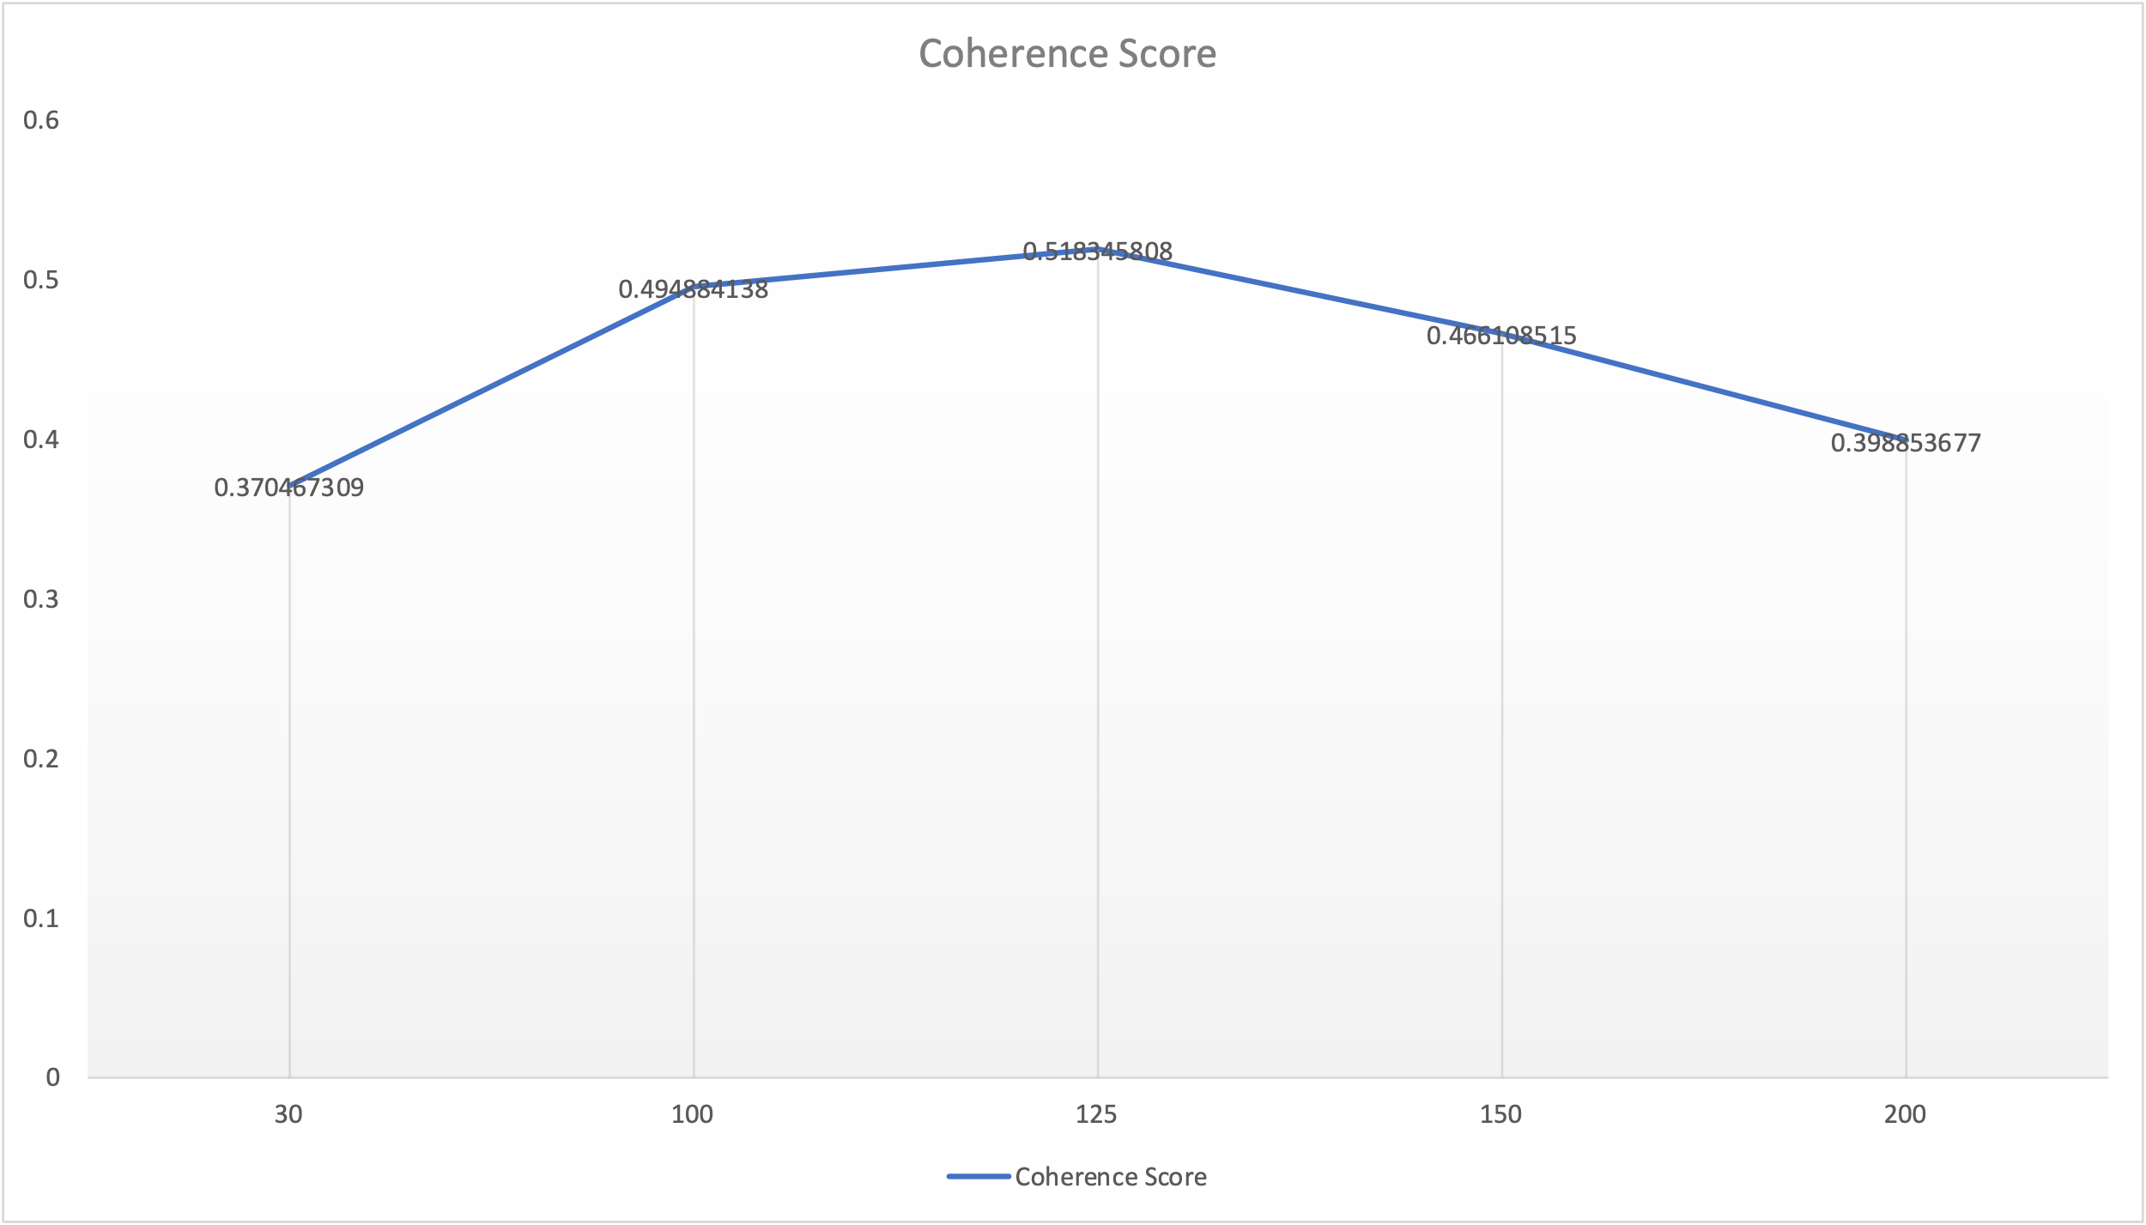

Figure 22. Coherence Score Comparison.

Figure 23 and Figure 24 show the topic visualization for genism and Sklearn LDA models. The Sklearn model with TF-IDF had apparent segregation of topics. However, it ended up classifying most texts under one Topic. In consequence, the genism model was used for the evaluations.

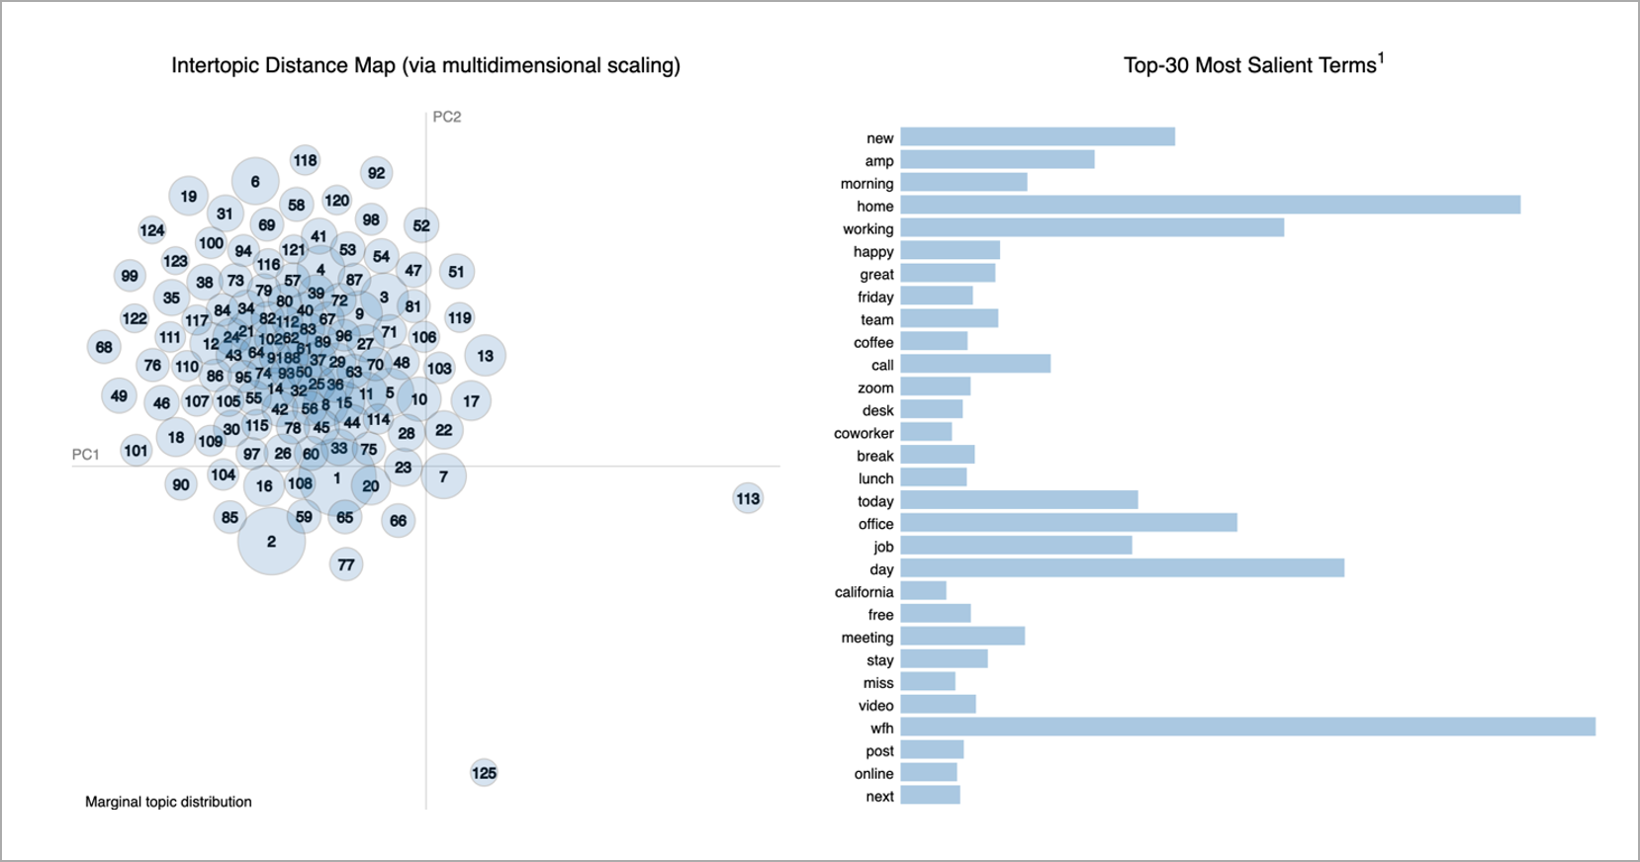

Figure 23. Top 30 Words from the Genism LDA Model

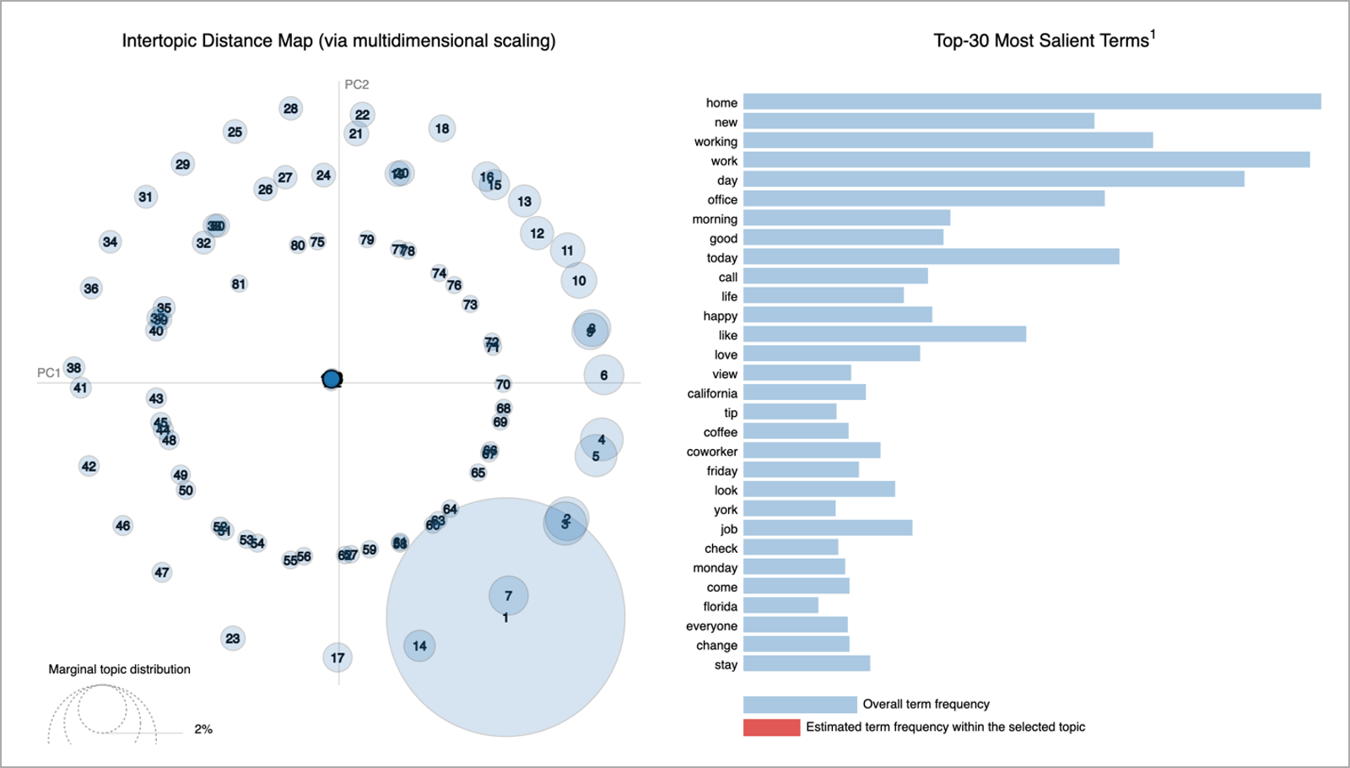

Figure 24. Top 30 Words from the Sklearn LDA Model

Figure 25, Figure 26, Figure 27 show the top three topics from the Genism model and their top 30 relevant terms.

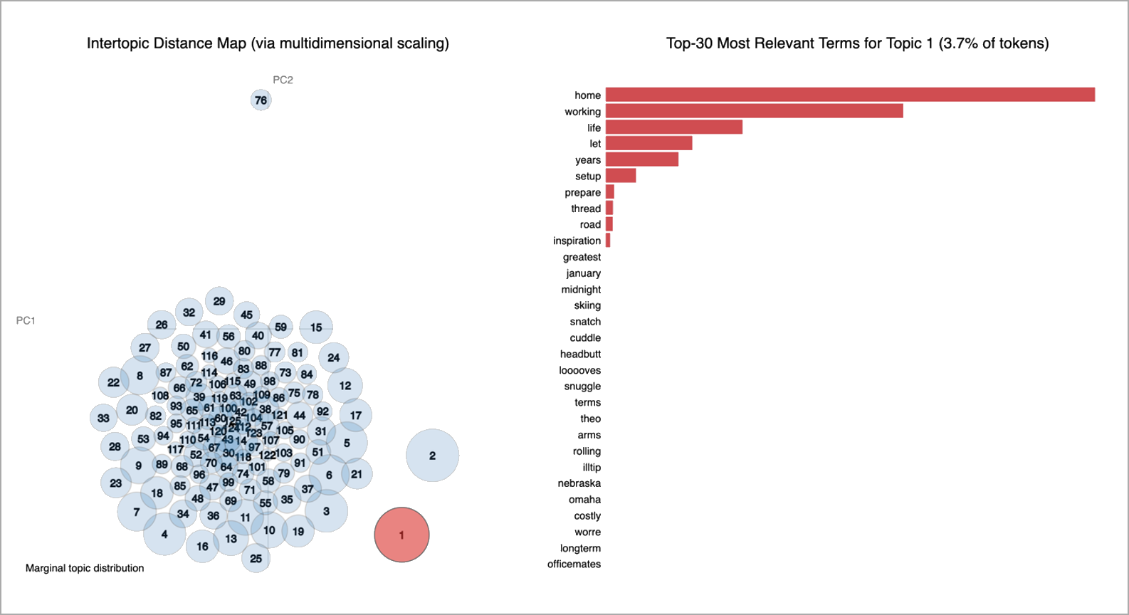

Figure 25. Top 30 Words for the 2nd Topic.

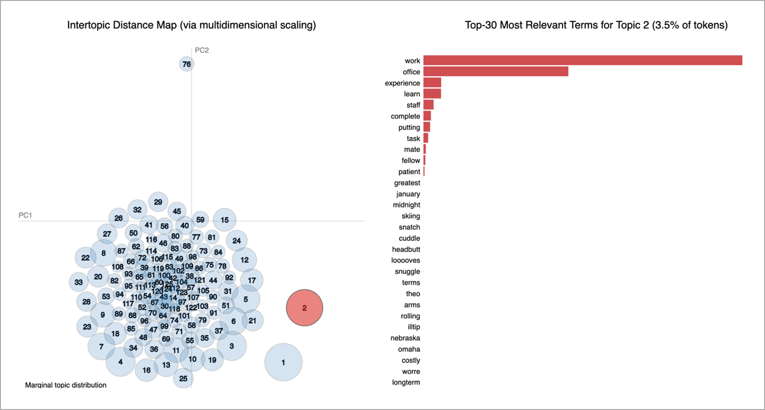

Figure 26. Top 30 Words for the 2nd Topic

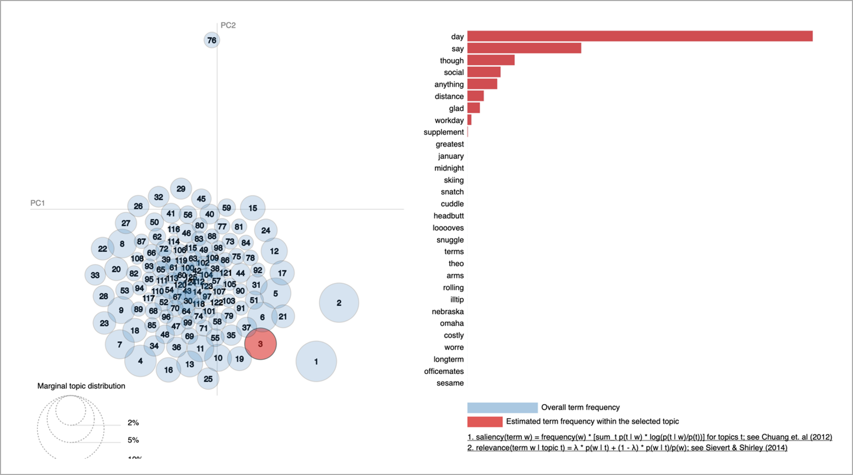

Figure 27. Top 30 Words for the 3rd Topic

Figure 28 shows the number of topics discussed over time. The number of topics discussed on Twitter went up during the COVID-19 outbreak and tapered later. People were talking more about topics related to work from home after COVID-19 than before. The Reddit topics did not see a significant uplift, indicating only a few people were using it, and they were the regular users of the platform.

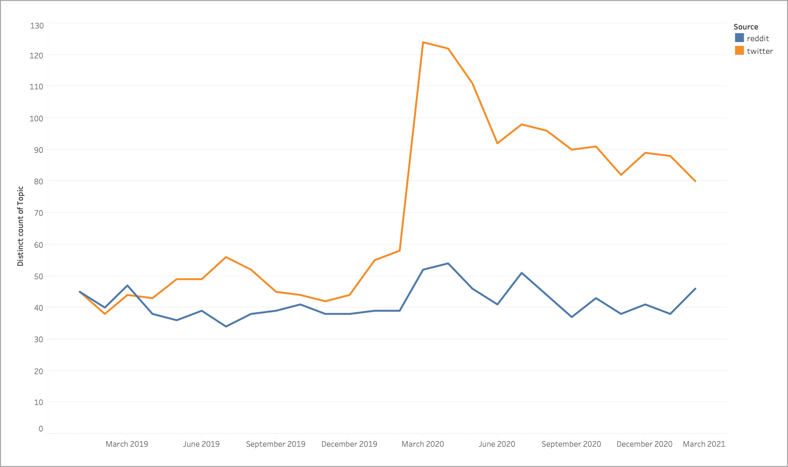

Figure 28. Number of Topics Discussed in Twitter and Reddit Over Time

The overall sentiment of work from home did not change much before or after COVID-19 started, as shown in Figure 29.

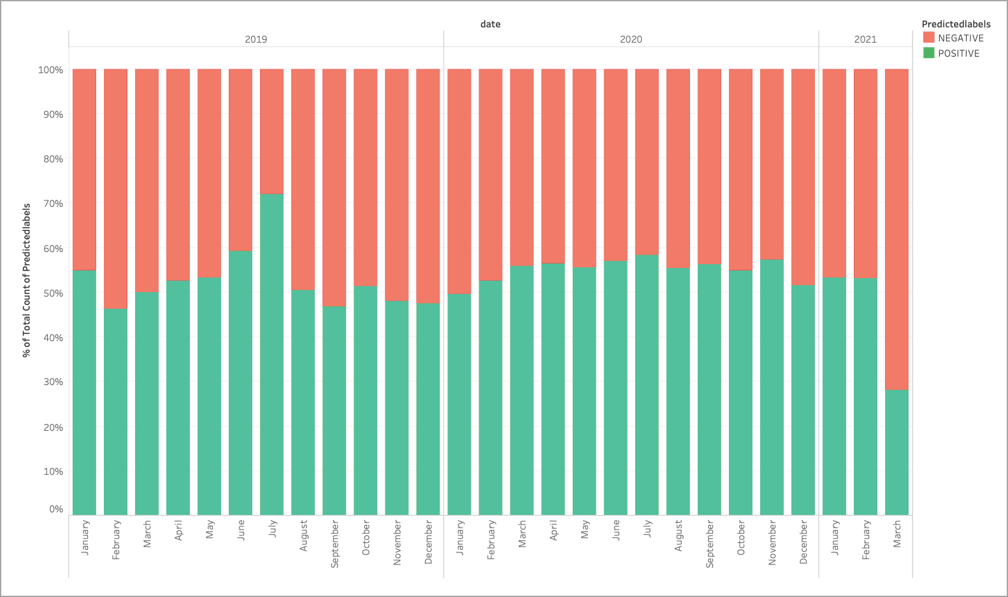

Figure 29. Percentage of Posts with Negative or Positive Sentiments per Month

Figure 30 shows the topics by their relevance across Tweets. The Main Topic is about work from home, which has various topics about work from home.



Figure 30. Topics by Frequency

Figure 31 shows the top 5 topic words from the top 20 topics; apart from the general work-from-home Topic, people talked about their breaks, office closures, general greetings, COVID-19 help, etc.

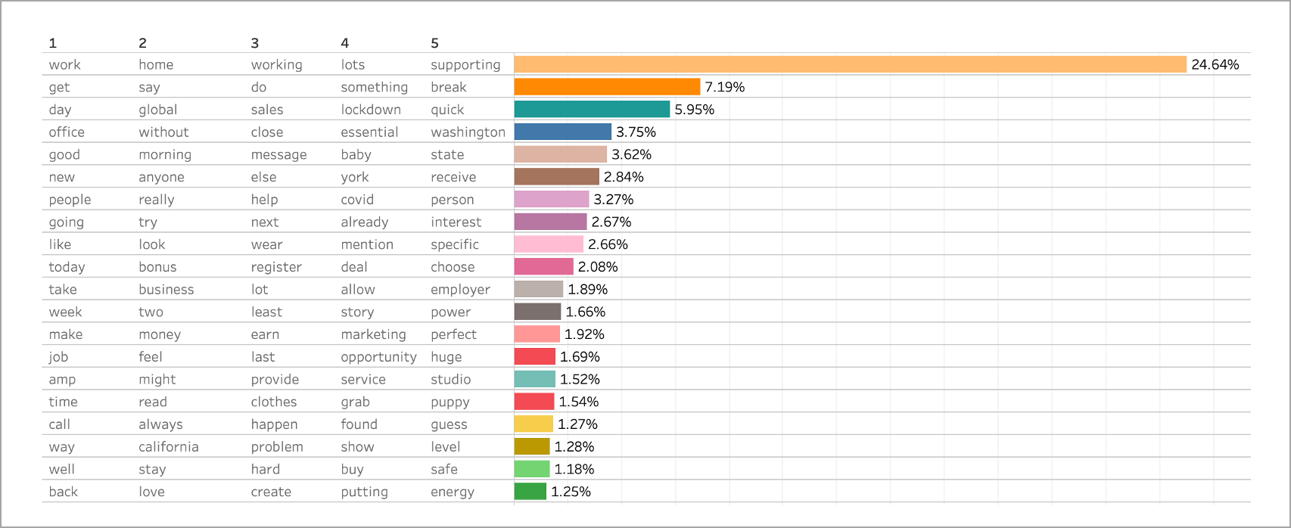

Figure 31. Top 5 Words from the Top 20 Topics

The other important aspect we noted is the lack of topics related to COVID-19 and schooling from home, which is expected to be part of working from home. In order to relate the topics with work from home, the API queries retrieved only posts that have the three work-from-home keywords identified by the Data Team. If the posts do not have these keywords, it not possible to relate their topics to what is on people’s minds when talking about working from home.

# Conclusion

At Big Business U.S.A., caring for the employee's state of mind and interests during the pandemic is very important. In response to the expressed interest among many employees in continuing to work from home after the pandemic, the HR department tasked its Data Team to conduct an initial study to understand how people feel about working from home, what else is on people’s minds relating to working from home, and whether the COVID-19 pandemic impacted people's attitudes and thoughts about working from home.

The study analyzed the postings on two popular social media sites, Reddit and Twitter, from about one year before the pandemic to one year after the start of the pandemic.

## How Do People Feel

The results found that the sentiments did not change much before and after the start of the pandemic; there was a slight change of attitudes from negative to positive after the beginning of the pandemic.

Sentiment before the pandemic was negative in Reddit and it stayed the same after the pandemic. Postings on Twitter, before the pandemic, expressed a positive sentiment. After the start of the pandemic, more posts had positive sentiment compared with before the pandemic started.

Figure 32 shows the distributions of the sentiments amongst social media before and after the pandemic and overall, for both Twitter and Reddit. Overall, the sentiment did not change much from before to after the pandemic started.

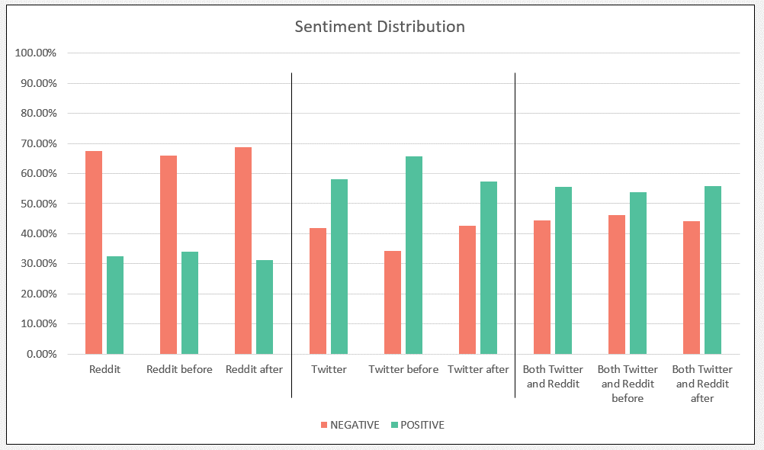

Figure 32. Comparison of Sentiment Distribution of Reddit and Twitter Postings Before and After the Pandemic Started

## What Is on People's Minds

In addition to sentiments, knowing what is on people’s minds when they talk about working from home might signal how they are coping. This study presented a method to extract topics from the collected Reddit and Twitter postings. Before the pandemic, the topics were mostly about work in general. After the pandemic began, there was a drastic increase of postings about work and a variety of new topics were introduced. As the months passed, postings about working from home reduced, and the number of types of topics decreased. Figure 33 shows the top 20 topics before and after the COVID-19 pandemic started.



Figure 33. Topics Before and After COVID-19 Pandemic Started

## Recommendations

As the next step, it is recommended that an automated system should be implemented to observe sentiments and topics discussed. Working with the Data Team, a more robust and thorough analysis can be set up to cover more postings from other popular websites, such as Facebook and LinkedIn.

Furthermore, Big Business U.S.A. could consider setting up an internal company social media site to give employees opportunities to express themselves. Adhering to the company's employee privacy guidelines, the automated system could review and analyze the postings regularly to inform the HR department about the general sentiment and interests among employees.

# Appendix

## Sentiment Analysis Results Of All Models

Figure 33 shows the results for Bernoulli Naïve Bayes, all vectorizers.

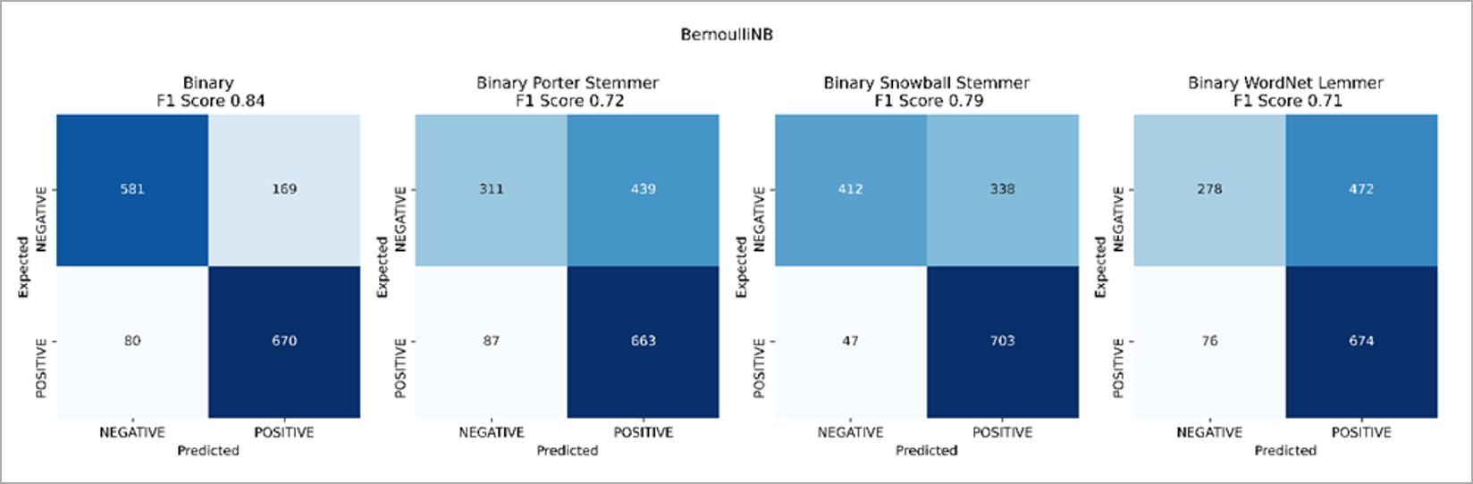

Figure 34. Bernoulli Naïve Bayes

Figure 34 shows the results for the Multinominal Naive Bayes.

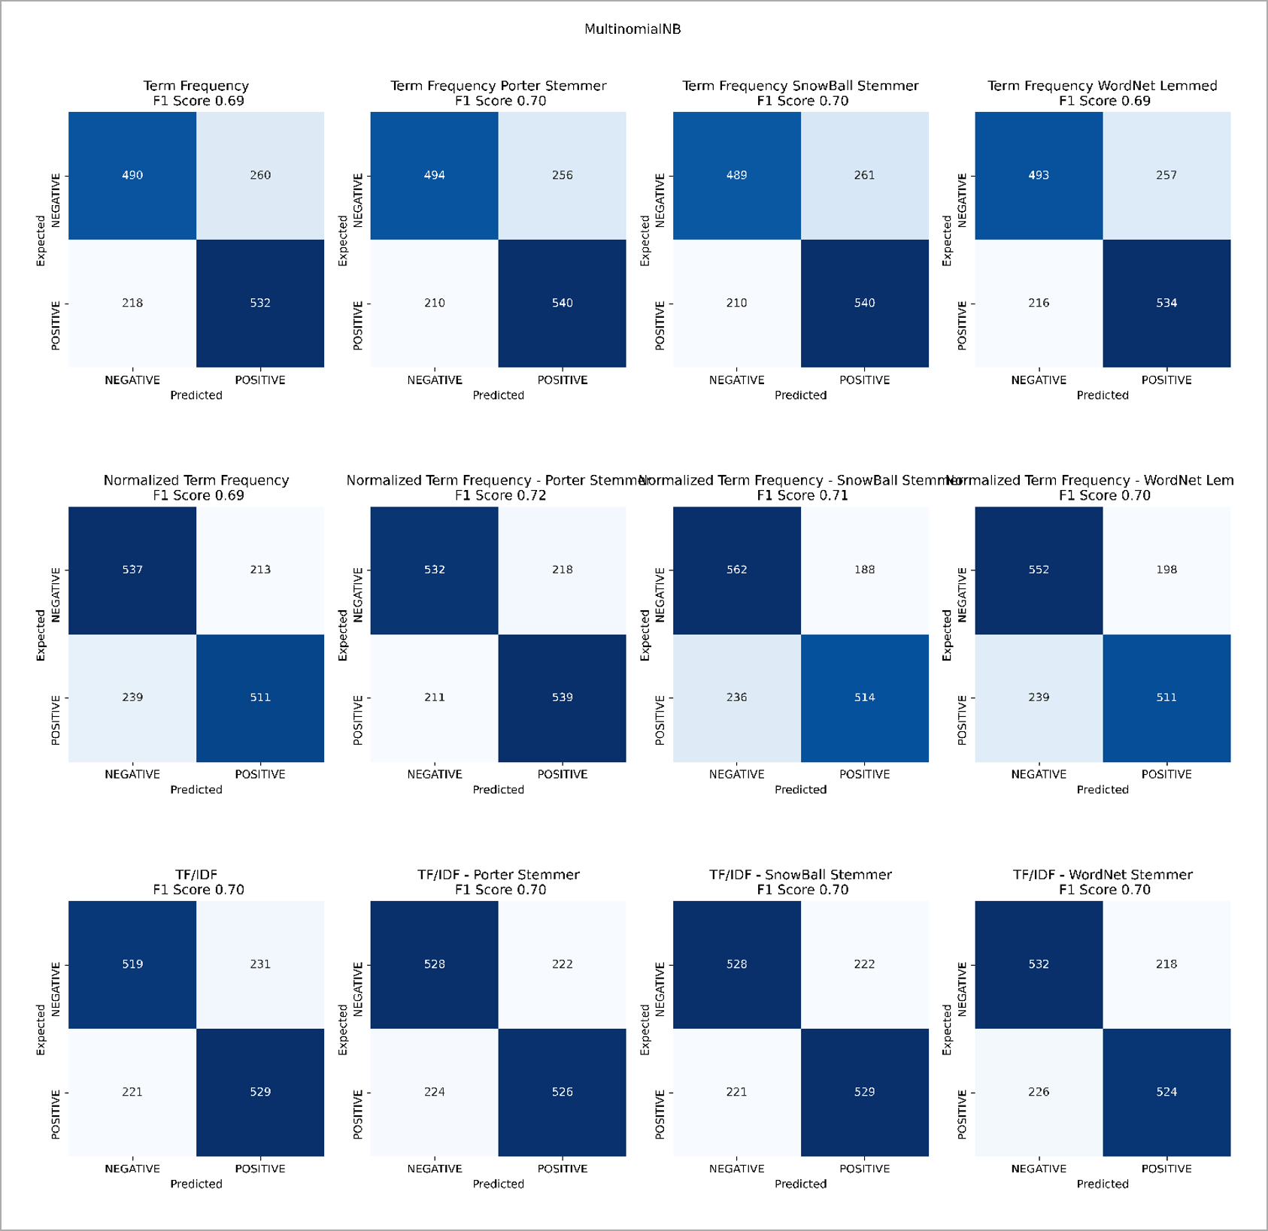

Figure 35. Multinomial Naïve Bayes Results

Figure 35, Figure 36, and Figure 37 show the SVMs Linear Kernel results for Cost 0.001, 1.0, and 1000.

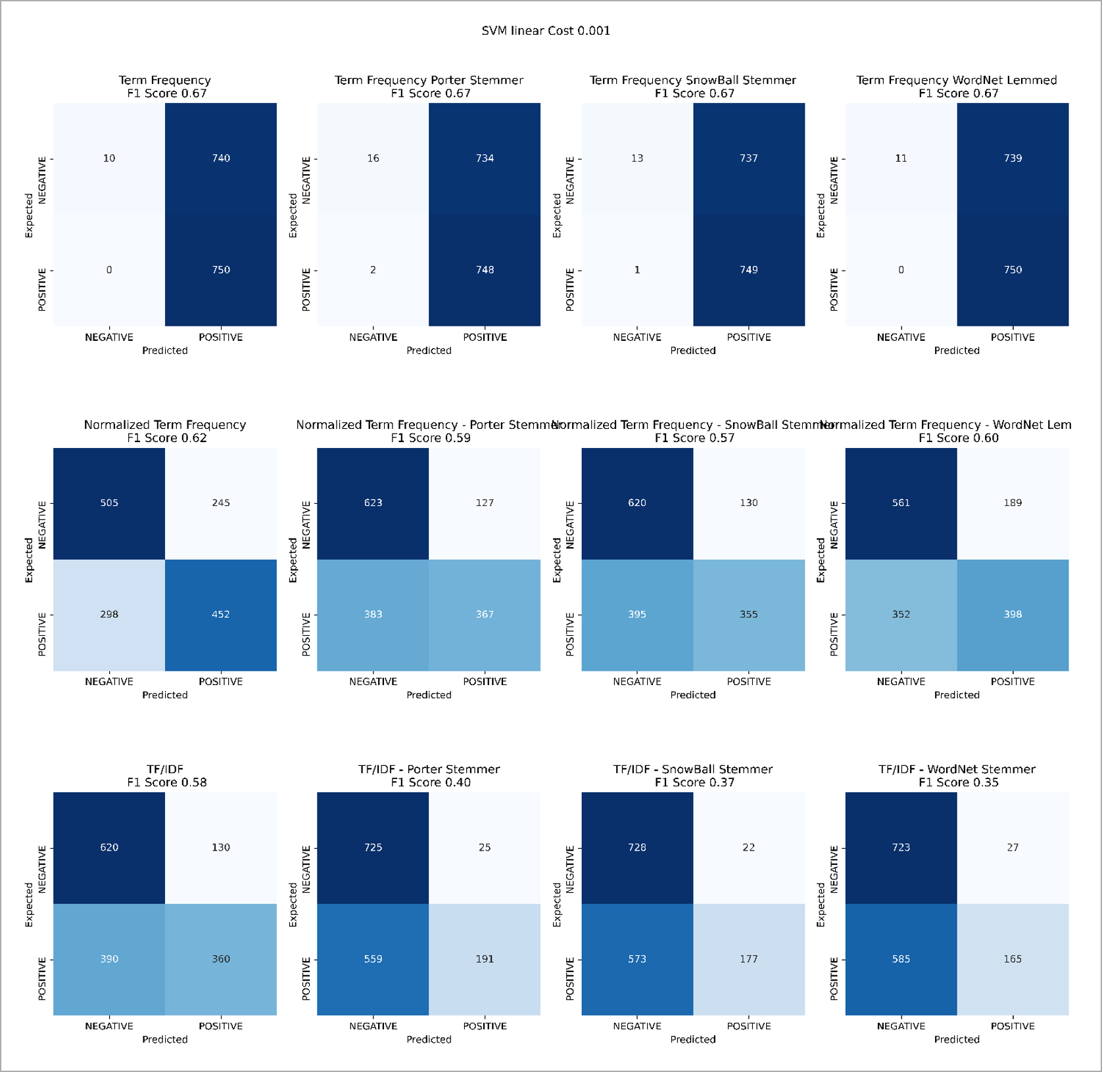

Figure 36.SVMs Linear Kernel, Cost 0.001

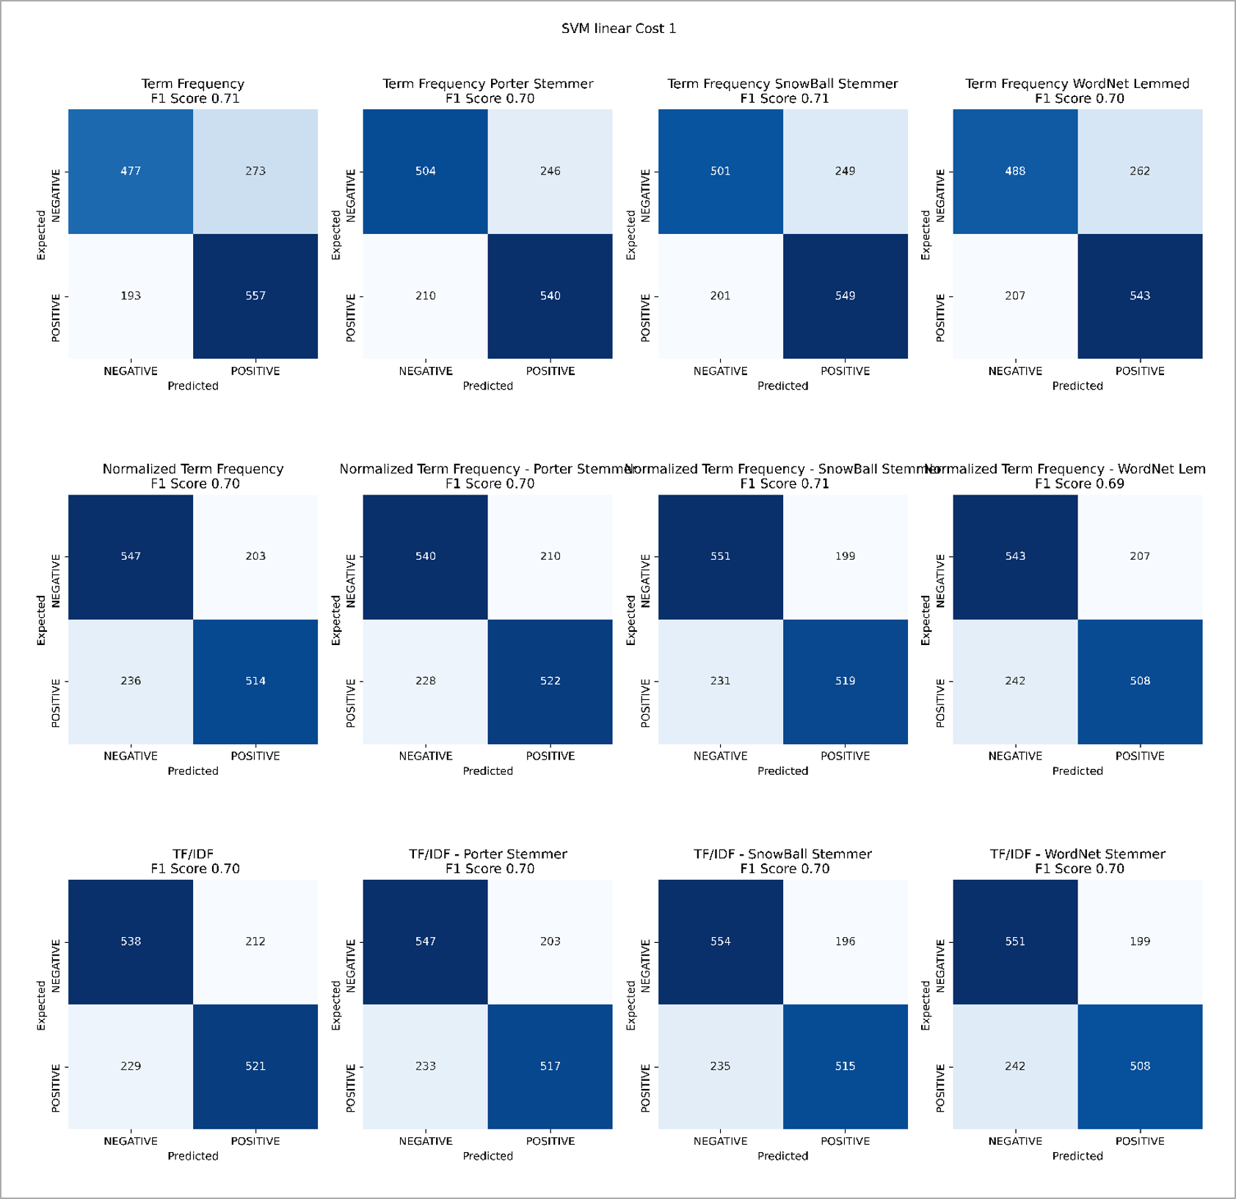

Figure 37. SVMs Linear Kernel, Cost 0.001

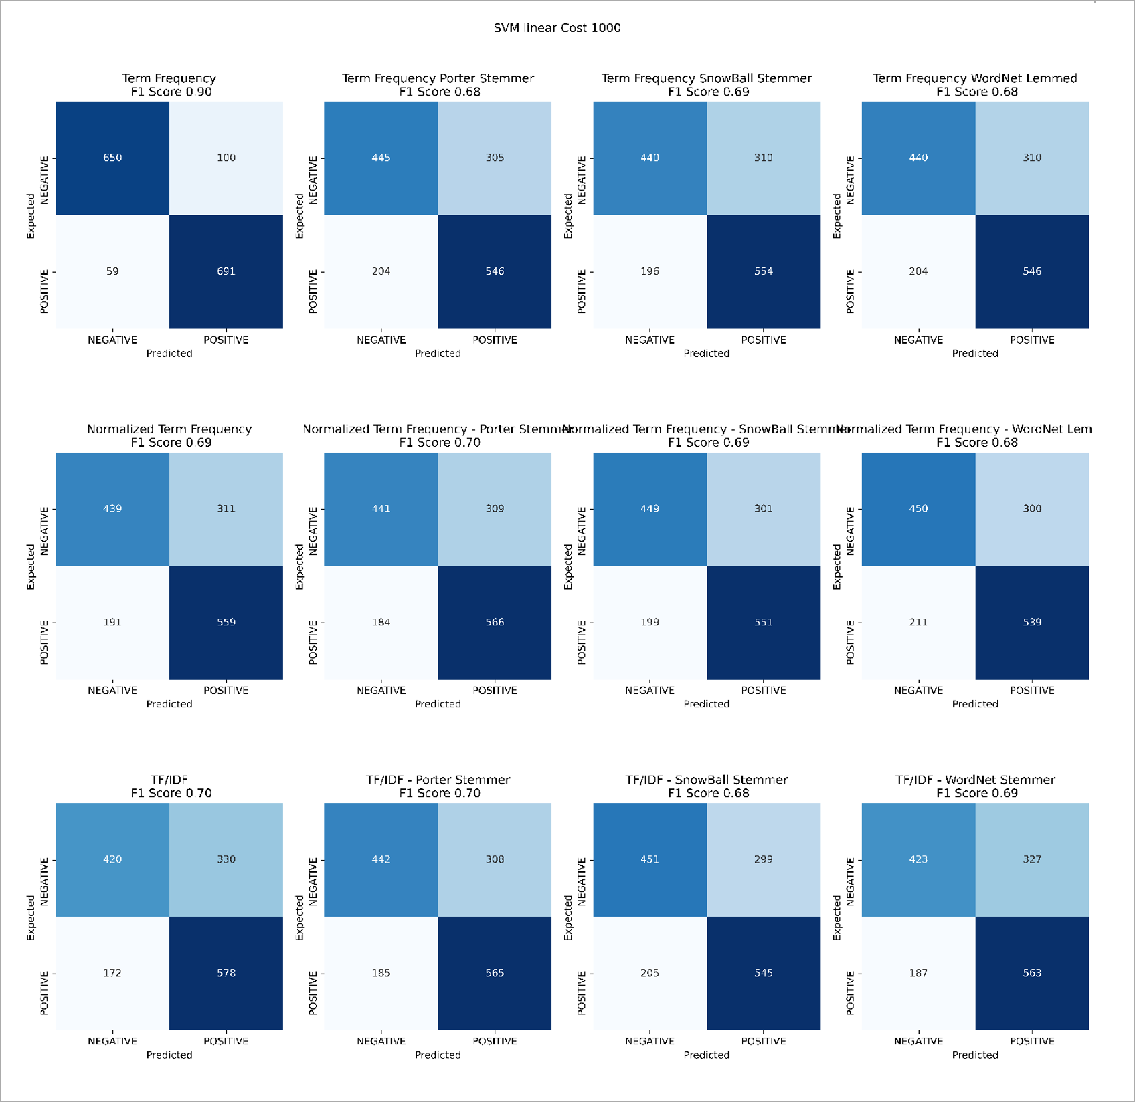

Figure 38. SVMs Linear Kernel, Cost 1000

Figure 38, Figure 39, and Figure 40 shows the SVMs Polynomial Kernel results for Costs 0.001, 1.0, and 1000.

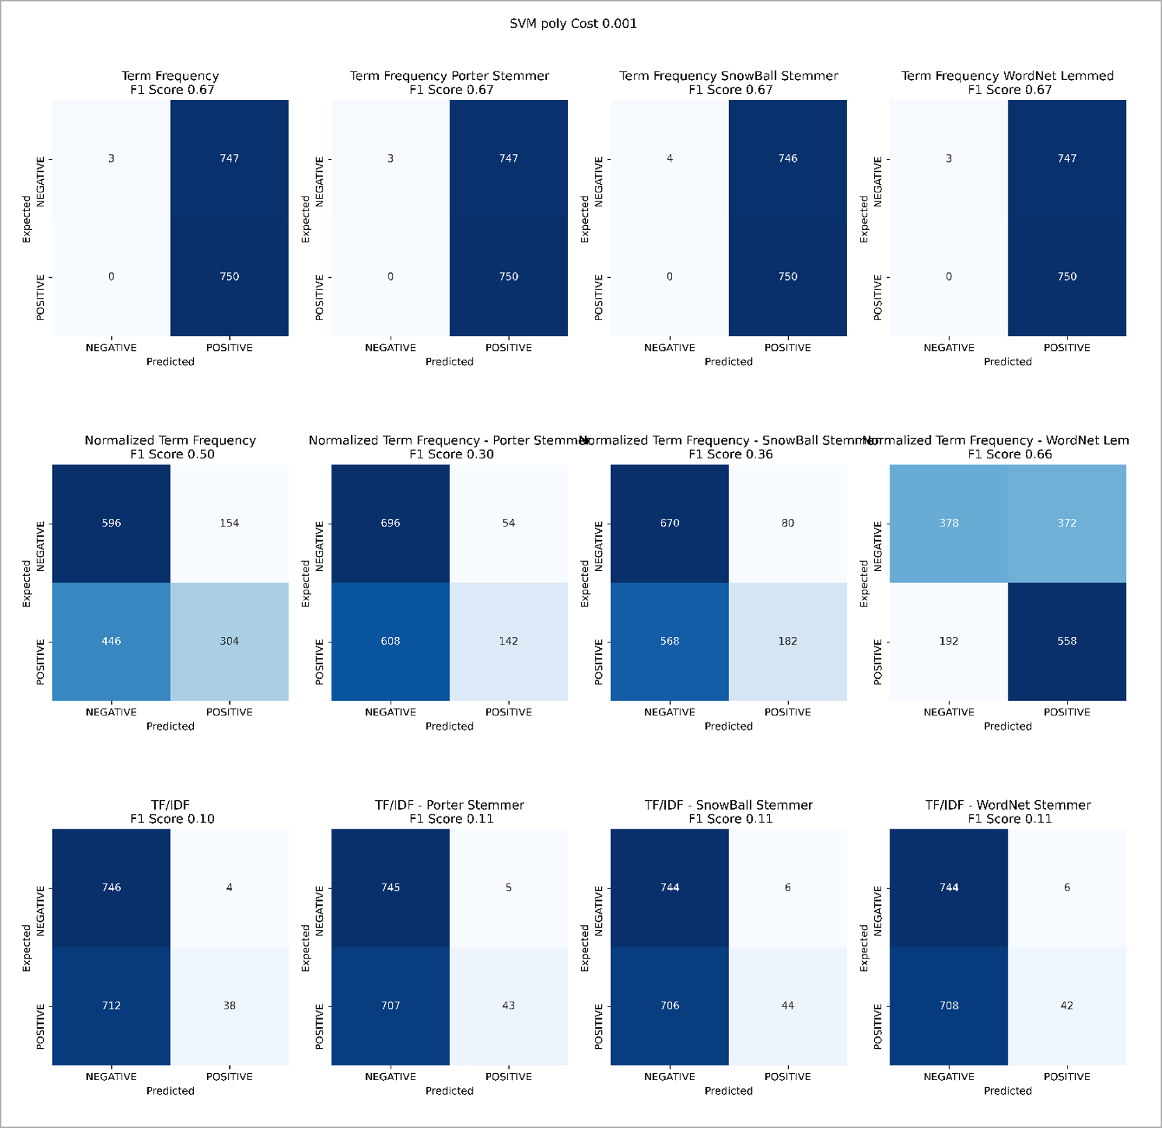

Figure 39. SVMs Polynomial Kernel Cost 0.001

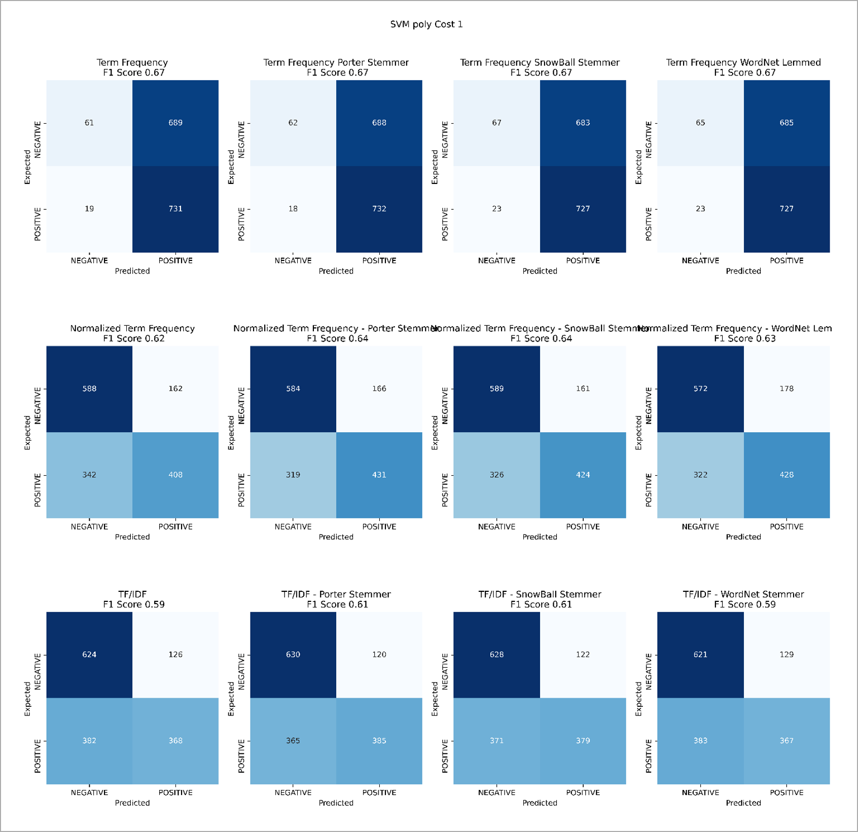

Figure 40. SVMs Polynomial Kernel, Cost 1.0

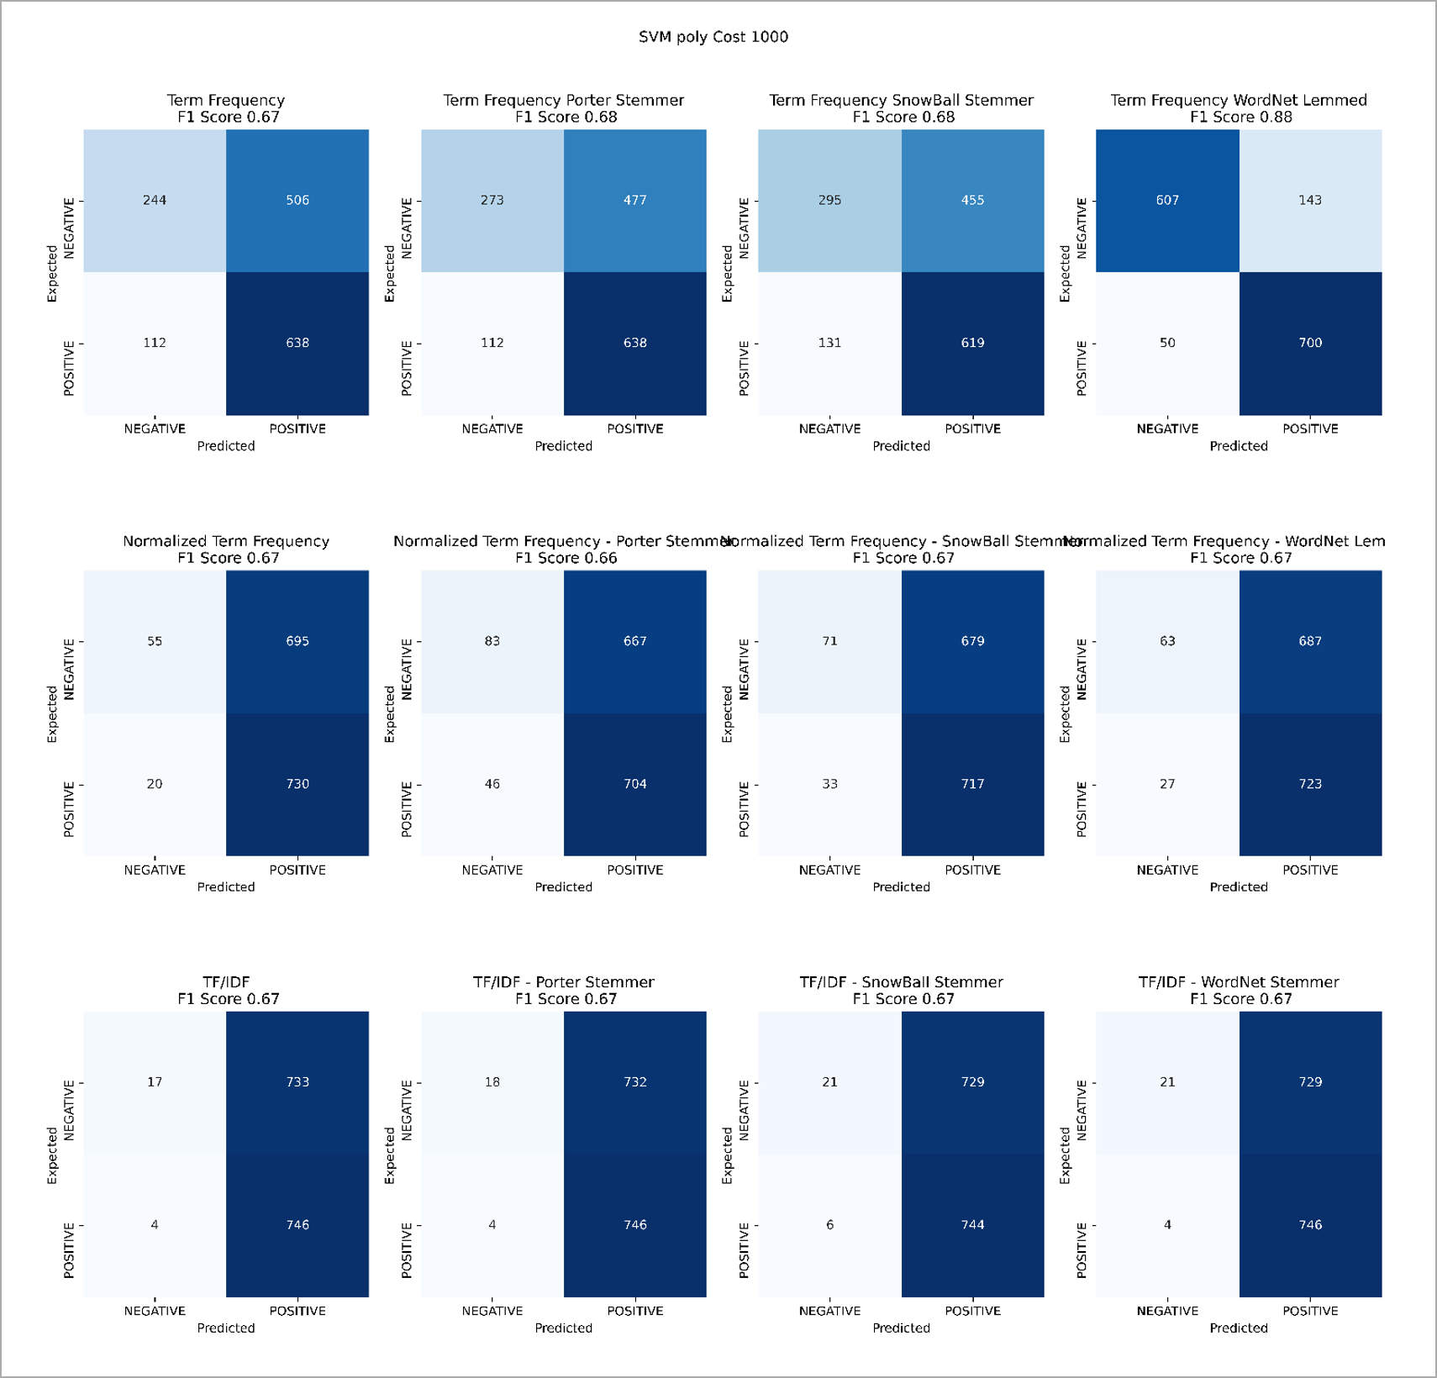

Figure 41. SVMs Polynomial Kernel, Cost 1000

Figure 41, Figure 42, and Figure 43 show SVMs Radial Basis Function Kernel results for Cost 0.001, 1.0, and 1000.

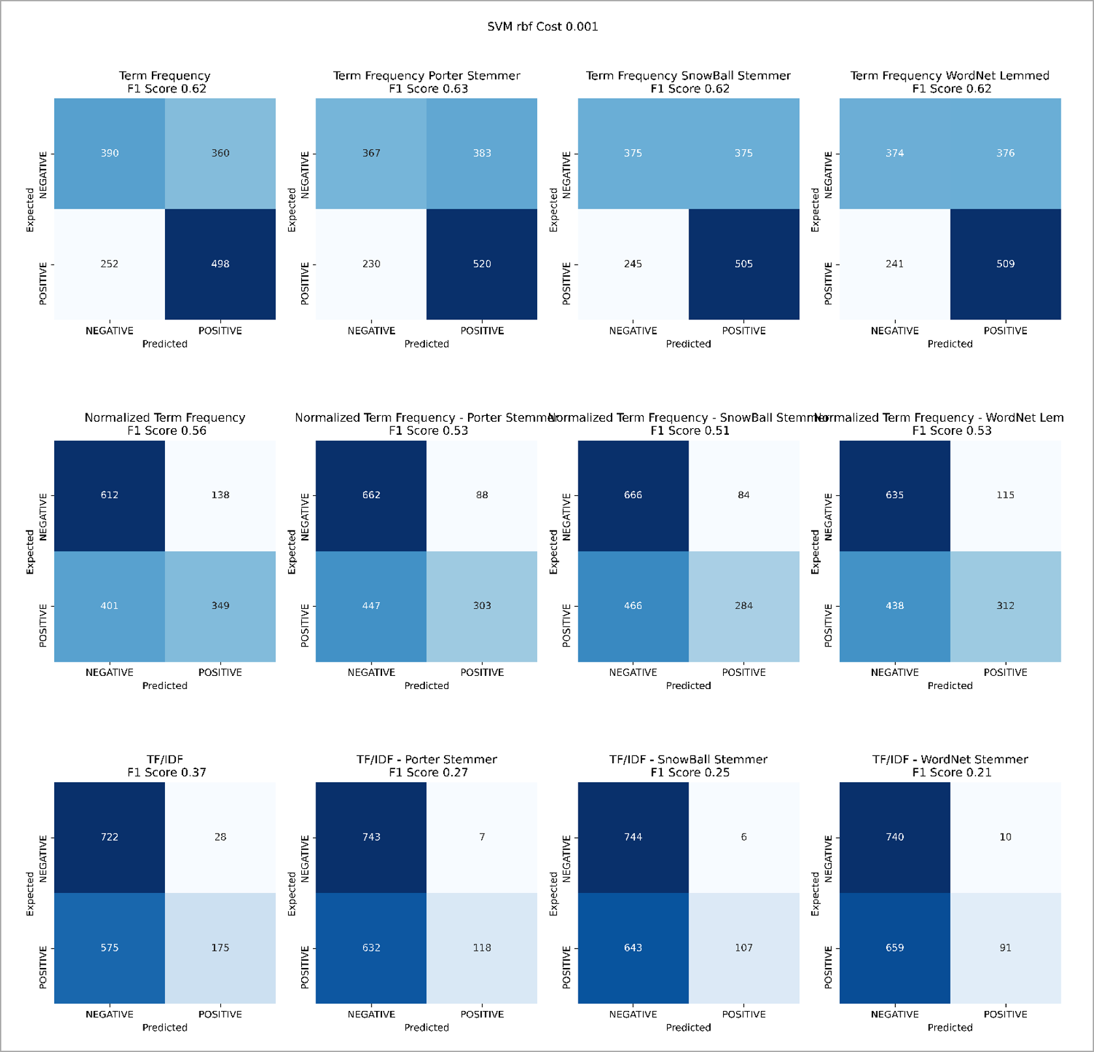

Figure 42. SVMs RBF Kernel, Cost 0.001.

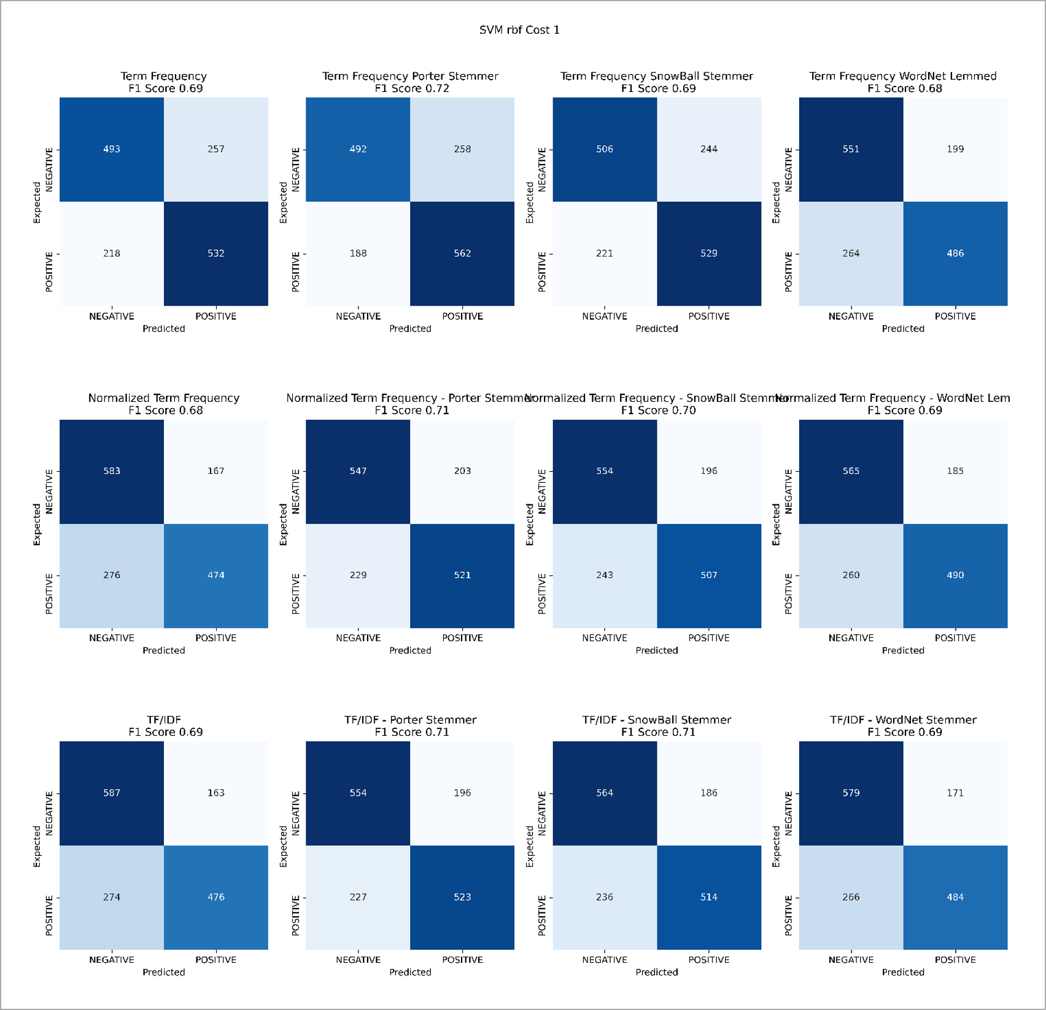

Figure 43. SVMs RBF Kernel, Cost 1.0

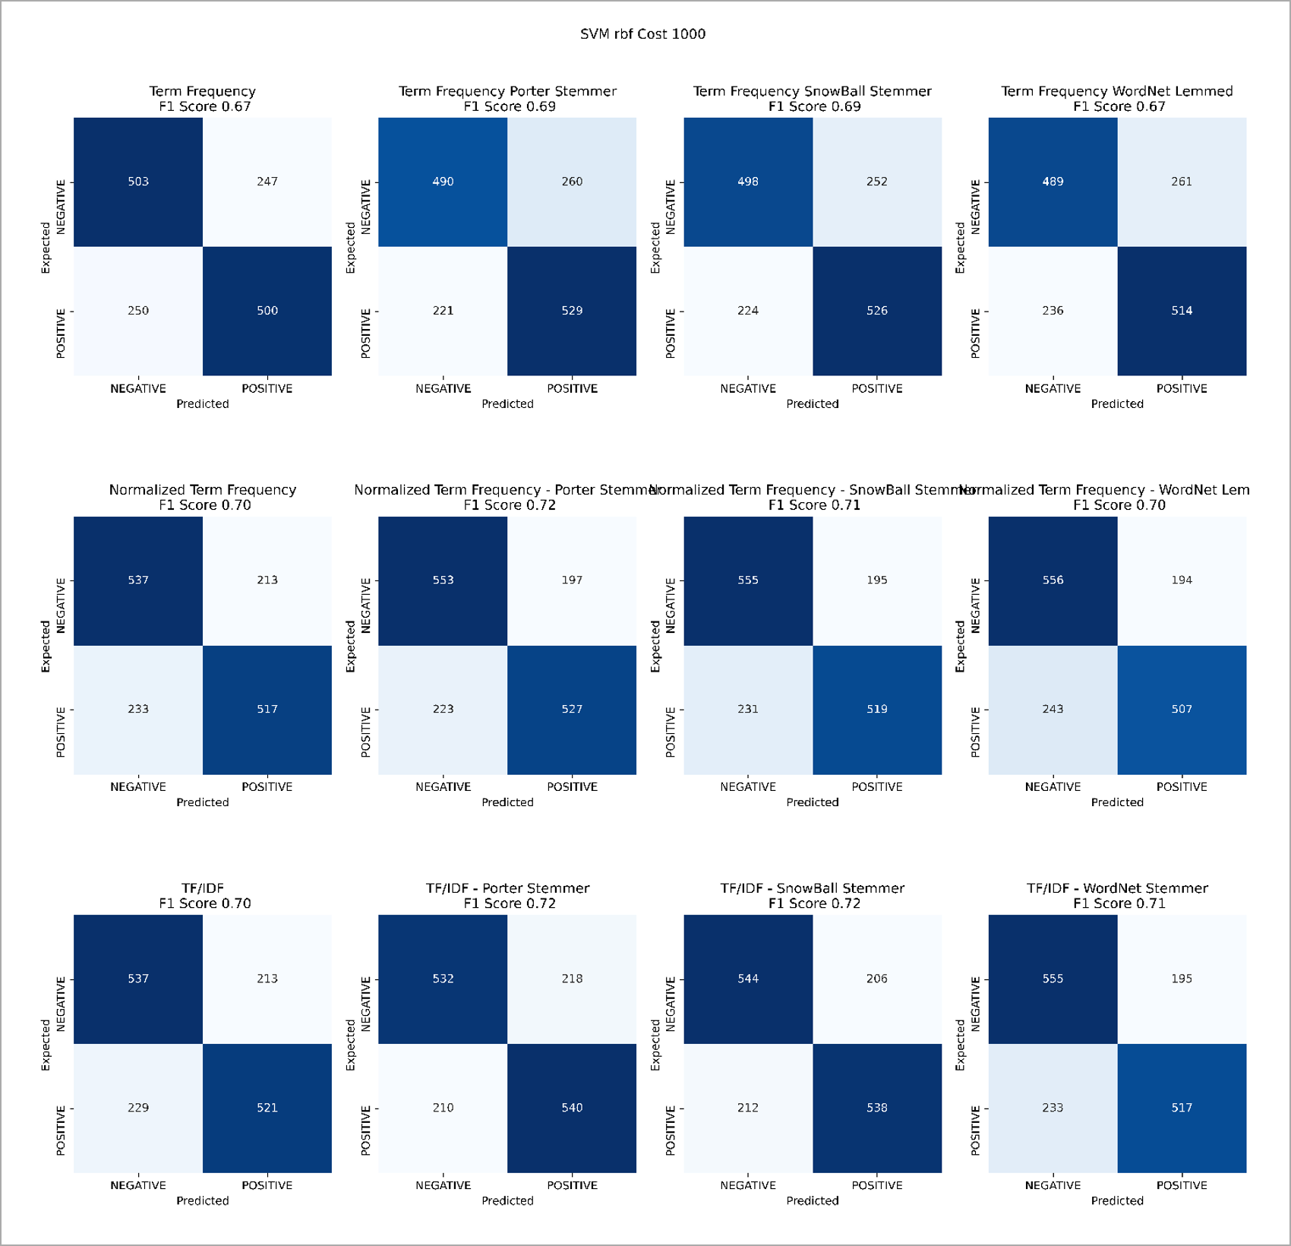

Figure 44. SVMs RBF Kernel, Cost 1000

1. Cammi Pham, “7 Things You Need To Stop Doing To Be More Productive, Backed By Science,” Observer, December 21, 2015, <https://observer.com/2015/12/7-things-you-need-to-stop-doing-to-be-more-productive-backed-by-science/>
2. Gad Levanon, “Remote Work: The Biggest Legacy of COVID-19,” Forbes.com, November 23, 2020, <https://www.forbes.com/sites/gadlevanon/2020/11/23/remote-work-the-biggest-legacy-of-covid-19>
3. Kim Parker, Juliana Horowitz, and Rachel Minkin, “How the Coronavirus Outbreak Has – and Hasn’t – Changed the Way Americans Work,” Pew Research Center, December 9, 2020, <https://www.pewresearch.org/social-trends/2020/12/09/how-the-coronavirus-outbreak-has-and-hasnt-changed-the-way-americans-work/>
4. Andrew Hutchinson, “Here's Why Twitter is so Important, to Everyone,” Social Media Today, March 18, 2016, <https://www.socialmediatoday.com/social-networks/heres-why-twitter-so-important-everyone>
5. David Curry, “Reddit Revenue and Usage Statistics,” Business of Apps, March 25, 2021, <https://www.businessofapps.com/data/reddit-statistics/>
6. “Transformer Sentiment Analysis,” <https://huggingface.co/transformers/quicktour.html>
7. Christopher D. Manning, Prabhakar Raghavan, & Hinrich Schütze, “Stemming and lemmatization,” *Introduction to Information Retrieval*, © 2008, <https://nlp.stanford.edu/IR-book/html/htmledition/stemming-and-lemmatization-1.html>
8. Great Learning Team, “Multinomial Naïve Bayes Explained,” greatlearning blog, September 20, 2020, <https://www.mygreatlearning.com/blog/multinomial-naive-bayes-explained/#advantages>
9. Rohith Gandhi, “Support Vector Machine — Introduction to Machine Learning Algorithms,” towards data science, June 7, 2018, <https://towardsdatascience.com/support-vector-machine-introduction-to-machine-learning-algorithms-934a444fca47>
10. Thushan Ganegedara, “Intuitive Guide to Latent Dirichlet Allocation,” toward data science, August 23, 2018, <https://towardsdatascience.com/light-on-math-machine-learning-intuitive-guide-to-latent-dirichlet-allocation-437c81220158>
11. “Latent Dirichlet Allocation,” Wikipedia, Accessed on March 26, 2021, <https://en.wikipedia.org/wiki/Latent_Dirichlet_allocation>
12. Sooraj Subrahmannian, “Learn to Find Topics in a Text Corpus,” Medium.com, April 16, 2018, <https://medium.com/@soorajsubrahmannian/extracting-hidden-topics-in-a-corpus-55b2214fc17d>
13. Gensim, “models.coherencemodel – Topic coherence pipeline,” <https://radimrehurek.com/gensim/models/coherencemodel.html>
14. Shashank Kapadia, “Evaluate Topic Models: Latent Dirichlet Allocation (LDA),” towardsdatascience.com, August 19, 2019, <https://towardsdatascience.com/evaluate-topic-model-in-python-latent-dirichlet-allocation-lda-7d57484bb5d0>